
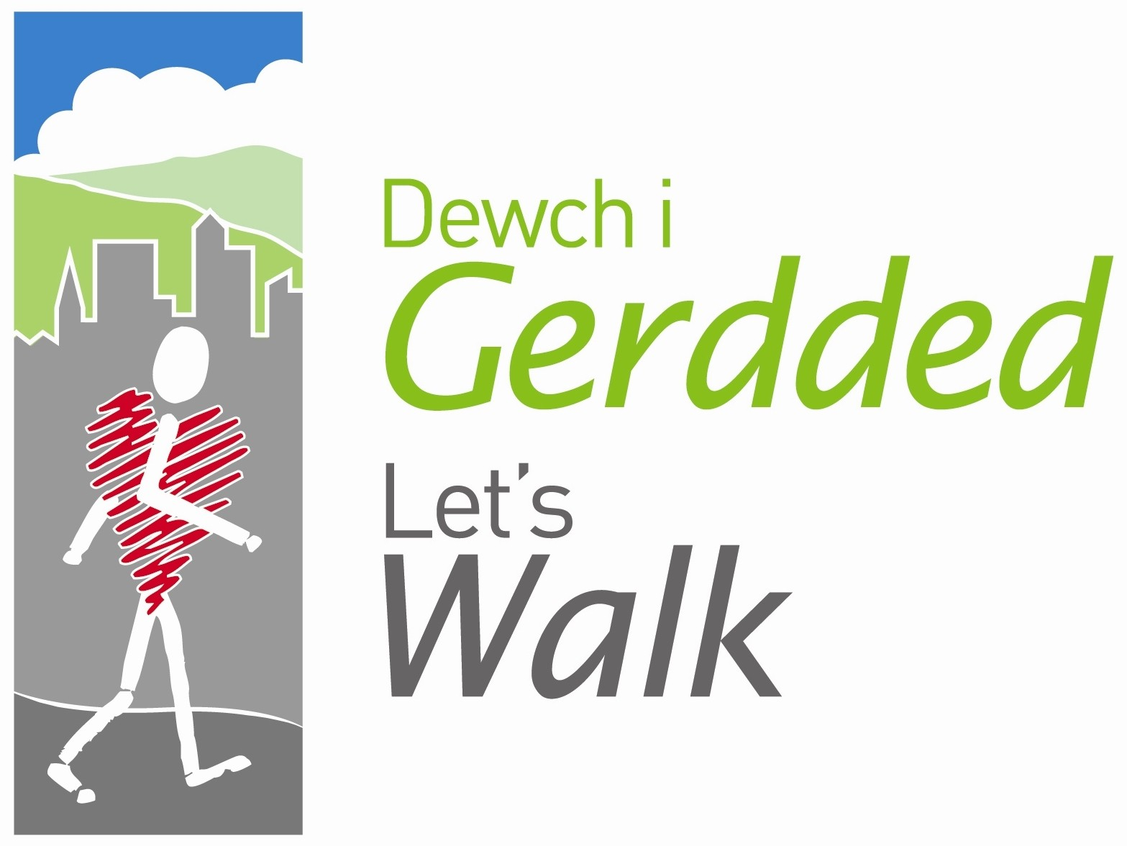




Peak Number 1:
Bickerton Hill and Maiden Castle

Height:
212m.
Distance to summit:
¾ mile, with optional extensions
Time to summit:
20 minutes to the true summit at Maiden Castle and another 15 minutes to the Kitty Stone
Difficulty:
Easy. A gentle climb on well-defined tracks
Directions:
From Wrexham, take the Nantwich road (A534) for approximately 12 miles. Keep ahead at Broxton roundabout, then take the next road on the right (approximately 500m at the top of the hill). At a cross roads in about 2 miles, take the road on the left, signed to Bickerton. Pass through two small hamlets, then, at a faded wooden signpost to Bickerton Hill, turn left up a sandy track to reach the car park.
Parking:
At Pool Lane car park, Bickerton (Grid Ref. SJ 503 531).

The Area
Bickerton is at the southern end of the long sandstone ridge of the Peckforton Hills. It is a particularly beautiful hill, with flanks clothed in oak woodland, and an upland of bilberry and heather. The highest point of Bickerton Hill is actually known as Larkton Hill, and this is where you will find the remains of an Iron Age hill fort by the name of Maiden Castle. The views from here are spectacular. Bickerton has a second summit, just to the north-east of the hill fort. Just a little lower, but with equally stunning views, this summit is crowned by the ‘Kitty Stone’ – a huge block of sandstone that has been dedicated to the wife of the benefactor who helped the National Trust acquire this lovely hill. There are many footpaths on Bickerton, and several suggested circuits. After visiting Maiden Castle, you could opt to continue to the Kitty Stone and perhaps even make a longer return through the woodland at the foot of the hill.
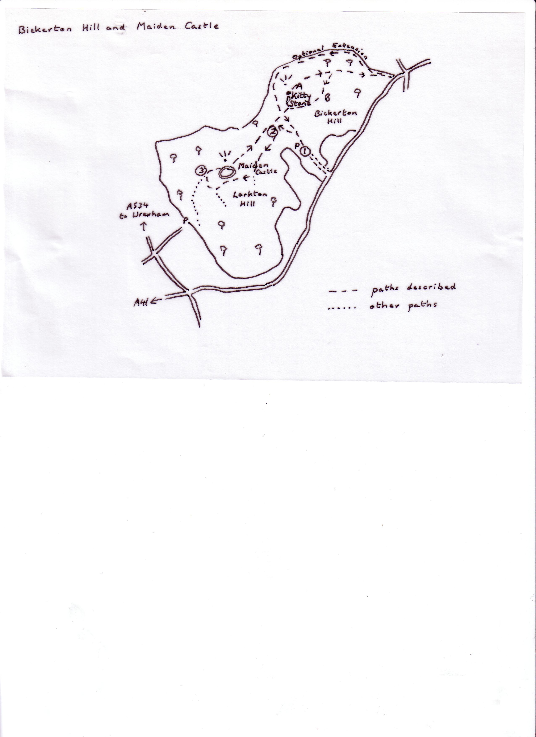
Directions for the Walk

- For the first part of this walk you are following the circuit designated by an arrow in a triangle, so start by taking the broad sandy track that leads uphill from the car park. After a couple of minutes, the triangle sign indicates that you take the track branching off on the left. Soon you reach a main track.
- On the left here you can see a flight of stone steps. Ignore them and take the path on the left – again the triangle is there to guide you. Keep with this path, passing a couple of junctions that are again marked by a triangle, until you reach an especially wide track. Turn right here and continue to the edge of the ‘cliff’, where a marker stone indicates that you have reached Maiden Castle.
- Go up the steps on the right to reach the best viewpoint, which is actually the path along the rampart of the hill fort. This is the place to pause and take in the view. If you then continue along this path (still following triangles) you will eventually come to the stone steps you saw earlier. At the foot of these you have an option – simply follow the triangle sign back to the car park, or keep straight ahead to visit the Kitty Stone.
- If you have chosen to go on to the Kitty Stone, you will be following the route of a long-distance footpath called the Sandstone Trail. It goes all the way from Whitchurch to Frodsham (34 km) but you will need it only for about 800m. Keep ahead past the broad sandy track from the car park and then turn left at the second signpost. This path will now take you right up to the Kitty Stone, take your picture here.

At the Summit
Maiden Castle was once a cluster of huts and pens all surrounded by a double rampart. The ramparts are most easily seen on the side away from the cliff and if you don’t mind a few overgrown paths, you can walk around the entire circle. It is thought that the fort was destroyed by fire around 3000 years ago.

Now for the view, which is basically the same from both Maiden Castle and the Kitty Stone. The Peckforton Hills stretch away to the north-west and you can see their highest point, Raw Head (227m), jutting out at the end of the line on your right. Much farther away and a little to the left, the line of white industrial buildings is Ellesmere Port on the Mersey Estuary and you can look along the shore of this estuary to Liverpool. On a clear day and with binoculars you can see the cathedral.

Some distance to the left of all this, there are more white buildings at Queensferry on the Dee Estuary. The higher land between the two estuaries is the Wirral. Can you see the sprawling houses of Chester in front of the Wirral? Again using binoculars, you should be able to pick out the cathedral. To the left of the Wirral, the first range of bumpy hills is the Clwydians, and farther left still you see the mass of the Berwyns. Far away in the south (left again) the Breidden Hills rise very dramatically from the plain.
The one on the end is Rodney’s Pillar – and it’s on our list of peaks!

An Alternative Way Down
A From the Kitty Stone, continue on the Sandstone Trail down
the slope towards the next path junction, and then take the
wide grassy path doubling back to your right.
B Reaching its end, turn right (gate behind you) and keep
ahead on the wide sandy track. Soon you pass the signpost
you met earlier, and then a second signpost indicating a left
turn to return to the car park.

Refreshment
There are two pubs not too far away. Nearest is the Durham Heifer, on the A534, just after the point at which you turned off it. The food is imaginative (a sandwich is not what you think!), and there is a small back garden for children.
The other pub is the Egerton Arms, again with a garden, at the junction of the A41 and the A534. Beside the Egerton Arms there is a picnic site with toilets.

