
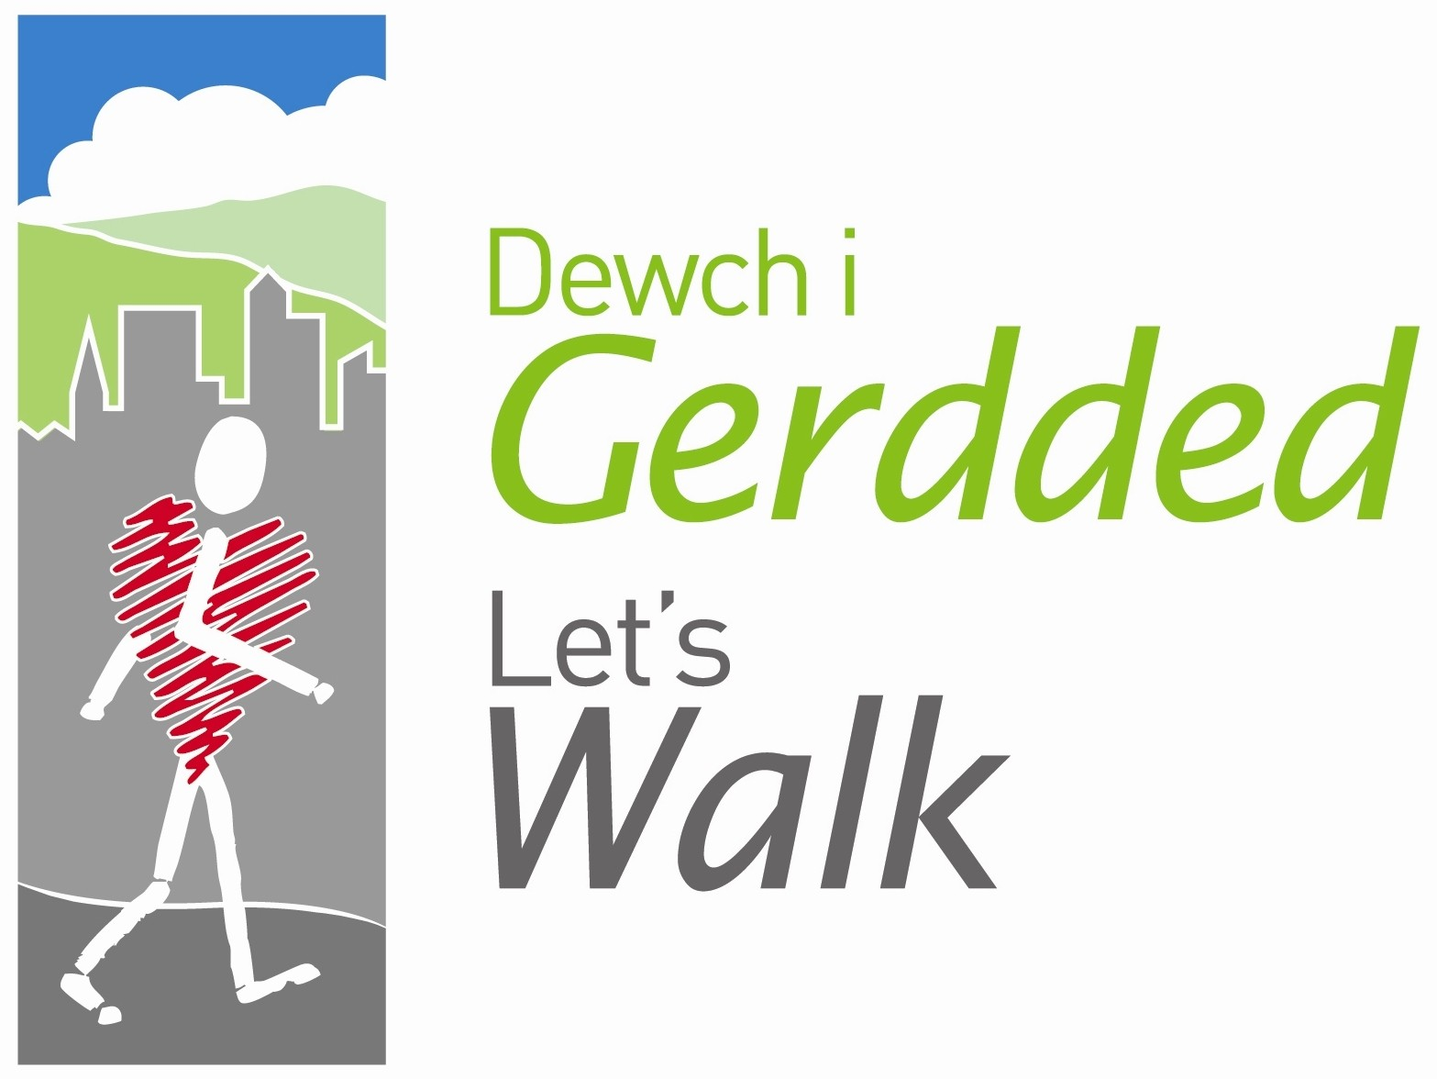




Peak Number 10:

Barbers Hill

Height:
368m
Distance to summit:
2 miles
Time to summit:
1 hour
Difficulty:
Moderate to Hard
Directions:
From Wrexham take A483 towards Chirk coming off at junction signposted ‘Plas Madoc Leisure Centre’. At roundabout take 3rd exit onto A539 under road bridge then immediately take 1st exit. At next roundabout take 2nd exit onto A539 signposted Llangollen.
Parking:
At the long stay P+D car park on the corner of East Street in Llangollen. Grid reference SJ214421
Map:
Explorer O/S map no 255 Llangollen and Berwyn

The Area
This walk is a good 4 mile circular walk from Llangollen along good footpaths, bridleways and country lanes with some stiff inclines. The walk takes part in part of the North Berwyn way and returns via Barbers Hill and Kill Me Quick lane, so called after a murderer was carried up to the Hill to be hanged and it was said that he asked his captors to ‘kill me quick’.
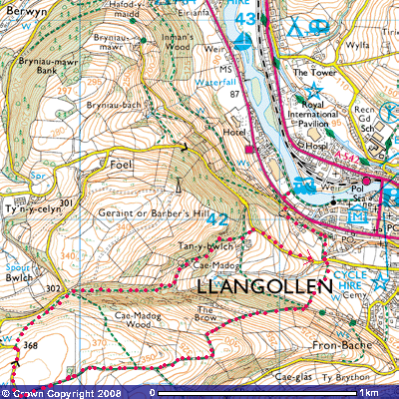

Directions for the Walk

- Turn right out of the car park and up to Market Street, cross over and go through the car park and exit at the top left hand corner on to the A5. Turn right and follow path to a Pelican crossing, cross over and turn right to a footpath sign and turn up 2 flights of steps. Cross over the lane into a small cul-de-sac, in the right hand corner, you will find a path behind the house and follow it up through a small wood to a lane.
- Cross the lane to a stile marked ‘North Berwyn Way’, cross it and go up over 3 stiles. Turn left for 10 metres and then right on to the Bridleway. Climb steadily for about a mile until you reach a lane, turn right on to the lane and walk along the lane for about 250 metres until you reach a small mound about 20 metres in. This is the summit of the walk where you can see panaromic views of the Llantysillio Mountains and the Dee Valley. Grid Reference SJ 198414.
- Go over the summit to a stile at the bottom of the field and cross on to a path through the bracken. Go over a second stile and go straight on (do not turn left) and follow path down to a bend in the lane. Turn right down a path through a small valley with trees on your left at the start and follow path down to a track.
- Turn left and follow path past a farm and a dovecote, as you pass the dovecote, turn right on to a path and cross 2 stiles to a lane. Turn right and follow the lane down to where the first stile was crossed and follow route back to the car park.

Refreshment
There are plenty of cafes and pubs in Llangollen to have food and drinks. If it’s a sunny day, why not pack a picnic?

