
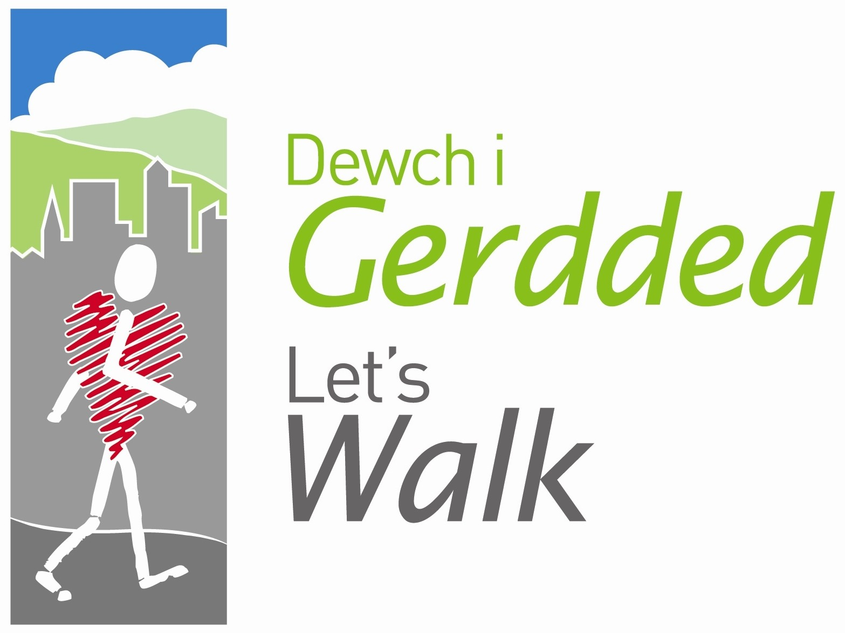




Peak Number 11:

Coed Llandegla Forest

Height:
150m
Distance to summit:
3 miles (part of a 6-7 mile walk)
Time to summit:
1 hour 20 minutes and up to 3 hours to finish the walk
Difficulty:
Easy to Moderate. The walk itself (6-7miles) is easy but the first climb on the Brown path (or summit for this walk) is quite a challenge even for the most experienced walker.
Directions:
Coed Llandegla Forest is located on the A525, 7 miles west of Wrexham. Head towards and through Coedpoeth and Minera where you will shortly leave the 30 mph zone on a long straight and turn left at the end signposted Gwynfryn. Carry along the road and turn left at the Moors Pub crossroads onto the A525. Turn left shortly after you pass the Llandegla fisheries. Follow signs to the visitor centre.
Sat Nav Reference; LL11 3AA
Ordnance Survey Map Sheet 117 Chester & Wrexham, 1:50,000
Parking:
Parking in the Visitors Centre (Grid Ref SJ 227520) is charged at £1.50 for 3 hours and £2.50 for the day. There is additional parking further up the trail so if the initial car park is full, follow the directions.
Other Considerations:
Dogs are welcome as there are no stiles, but must be kept under control and shouldn’t be allowed to foul the area. Please be aware that all walks may pass through areas where timber harvesting operations are taking place therefore caution should be exercised at all times. Sensible footwear is recommended. You may pass horse riders. At some points, mountain bikers will also cross the path to continue on the cycle trails.

The Area
This walk isn’t technically a Mini Mountain but the walk has beautiful views, woodlands and two steep inclines and is often unknown to local families so we thought we would include it. At the Visitors Centre you will find a leaflet with all of the walking routes available to you (on CD also as sometimes they run out). All routes start from the Visitors Centre and are clearly signposted using different coloured footprints. Print or pick up a leaflet and follow the brown footprint signs for the long walk route.

This walk starts by sharing the climb to the spruce plantation with the Intermediate route, then the route continues to the far end of the forest. You will pass areas of forest that have been thinned for the black grouse (detour available to the bird hide), and which offers views of Black Grouse at certain times of the year. The final section is again shared with the Intermediate route.

Directions for the Walk

- Turn right out of the Visitors Centre and follow the road that bends up the hill in a S shape. Follow the Brown footprints throughout the walk.
- Where the walk goes into the woods, you can choose to stay on the road as it will always meet back up at a later point.
- After 1 mile you will pass areas of forest that have been thinned for the black grouse and which also offers good views of the countryside. If you fancy a quick trip to the Bird Hide, follow the purple footsteps for the ‘Black grouse route’ which will link back into the brown walk later on.
- The next mile is the hard part, stick to the track and climb uphill.
- Follow the path and start descending downhill, after approx 1 mile you will see a clearing of the trees on the left hand side and spectacular views of Moel Famau. A bench on the cycle path in front of you denotes the ‘Shotton View’, take your picture here and if you can, get the bench in the picture!
- Continue following the path and when you reach the T junction, follow the signs downhill. You may see cyclists at this point as the beginner and intermediate cycle paths intersect with the path further on.
- Follow the path again until another T Junction where you can follow the brown path around Larch bank and to the Visitors Centre to finish however we recommend the ending below.

An Alternative Ending which we recommend!
At the T Junction mentioned above, leave the brown trail before the loop around Larch Bank begins and turn right at the junction. Follow the Orange trail up the hill, shortly leading to the Reservoir. Turn left at the Reservoir and join the ‘Black Grouse walk route’ signposted with a purple footprint. This path leads you around the Reservoir, another photo opportunity and a chance to spot some fishermen’s catches! Follow the woodland path which meets back with the road you started out with which leads back to the Visitors centre. This last road is shared by both walkers and cyclists so please keep an eye peeled for speedy bikes!

Refreshment
The Visitor centre includes a Café, shop, toilets (outside at the rear of the building) and benches outside to picnic. The BMW Good Food Guide Ride recommends the Café as serving the ‘Best Bacon Buttie in the UK’.
Trails, car park and toilets are open 7 days per week however the Visitors Centre is closed on Mondays. In the summer, opening times are 9 – 8pm and in the winter, 9 – 6pm.

