
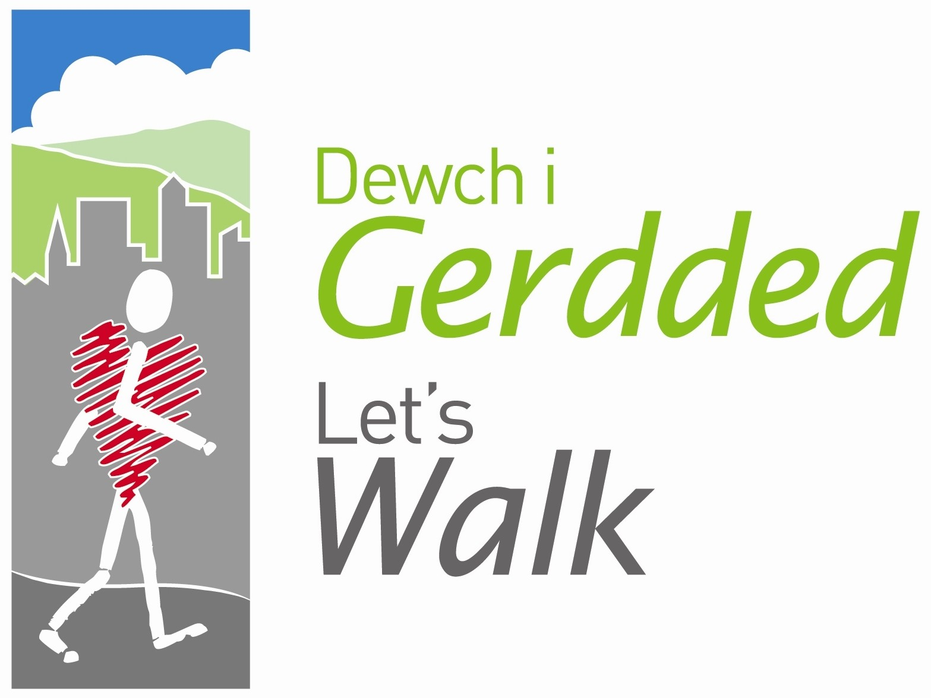


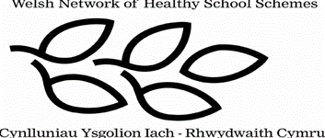

Peak Number 12:

Brymbo

Height:
141m
Distance to summit:
3 miles
Time to summit:
1 hour 20 minutes
Difficulty:
Easy. Steeped in history, this walk takes part in a hilly village so it isn’t really a ‘Mini Mountain’ but the views at the ‘summit’ rival other walks in this collection.
Directions:
Come off the A483 at the Coedpoeth junction and take the A525 Ruthin Road (heading towards Coedpoeth). Turn right signposted Brymbo and continue along Higher Berse Road, take the second turning on the right signposted Brymbo. Follow the bend around and turn right at the end shortly passing under a railway bridge and through the Lodge. Continue on the main road for 2 miles which should start narrowing with cars parked on both sides. Turn a steep and sharp left at the ‘Pen-y-Garth’ Residential Home and continue up High Street. With the cemetery on your left and P Williams Chemist on right, turn right as directed by the parking sign. The car park is now on your left hand side.
Parking:
There is a free car park opposite St Marys School in Brymbo.

The Mini Mountain
This walk emalgamates 3 walk routes designed by the Brymbo Heritage Group and has spectacular views.

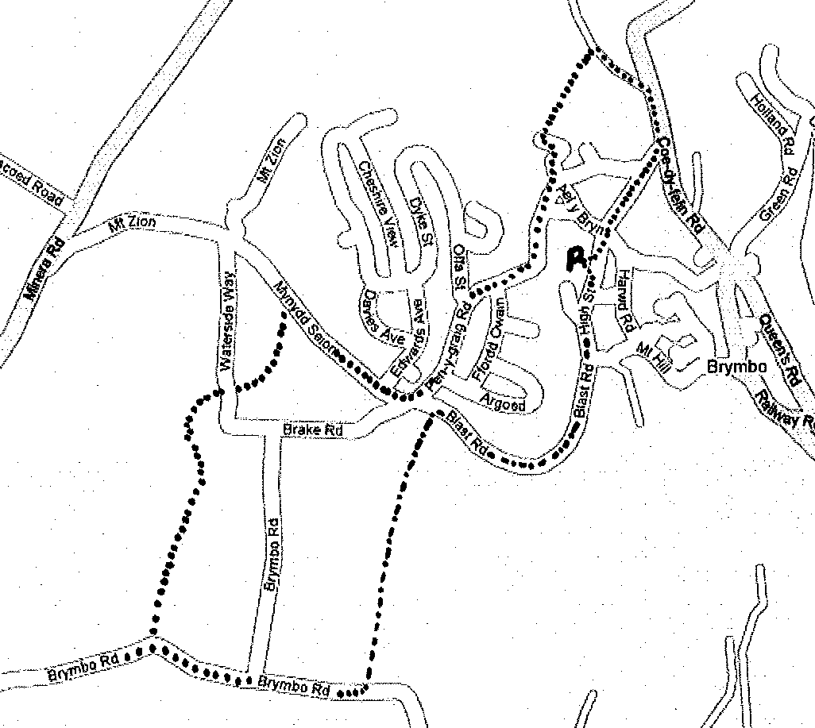

Directions for the Walk

- Walk down the hill from the car park in the direction you just came but turn right at the Chemist and continue up along High Street once a bustling place with many shops.
- On the left before the cross roads is the ‘Garden of Remembrance’ which had been the site of two churches. Part of the church collapsed in 1869 and its replacement built in 1890 was unstable and demolished in 1977.
- Continue in the same direction along Gwalia past the Miners Arms and onto Blast Road (so called after the Blast furnace at the Steelworks). Iron Ore, coal and lime were top loaded into the furnace and burned to extract the metal from the minerals in the process called the Blast. Along Blast Road on the left is the newly created Brymbo Enterprise Center. Continue on the road as it bends around to the right.
- As you are approaching the cross road (Pen-y-graig road on
right and Brake Road on left) look for the footpath sign across
the road on the left hand side.
- Follow the footpath sign, there is a metal fence on the right that runs the length of the path. The way runs alongside the Wonder bank, the slag heap from the Wonder Colliery and the nearby Blast colliery. You will shortly come to a solid metal boundary, dogs and children will need to be picked up to pass over.
- Turn right, keeping alongside the high bank along until you reach the stile. This path can be very muddy if it has rained. Pass over the stile which is very high so children will need help, if you have a dog, you may have to carry them or use the opening in the barbed wire fence. Continue along the grass path leading around the right of the hill, however for some spectacular views, walk up to the top of the hill.
- Go over second stile which has a gap for dogs and follow path in front with the Grid Station on your right, before emerging onto Brymbo Road. Turn right and walk on the road BE CAREFUL as there are NO pavements.
- At cross road, carry on straight over, past the derelict Sarn Chapel (built in 1899) shortly on the left and follow road until you reach Pen Rhos Engine House on right. It was built at the end of the 19th Century by Iron Master John Wilkinson to pump water from an adjacent coal mine.
- Double back the way that you just came and immediately turn left following footpath sign by the farm. You will immediately go over 2 stiles over muddy boggy land (alternative route further on) and soon join a former tramway which served the Pen Rhos Colliery. Follow the path onto and along Waterside Way where there is a good view of Offas Dyke. ALTERNATIVELY if you do not wish to get muddy, walk back to crossroads, turn left and follow road (Be CAREFUL OF CARS), turning left at sign for ‘Berse Road’ you will shortly come to the footpath sign on left signposted ‘Penrhos’. This is where you would have come out if you had gone over the stiles.
- Quickly visit Top Pool (further up the road on the left) a reservoir from which water was piped to the Steel Works. Across the road from the footpath sign, go through the gate that leads to a path with the football pitch in view. Follow path and at junction, keep on ahead, through second gate, turning right onto main road.
- Pass ‘Edwards Way’ on left and take next left onto Pen-y-Graig Road and follow it up to a point where the road bends to the right and the Cheshire Plain comes into view.
- On the right is the ‘Pen y Graig’ Monument which commemorates Brymbos Industrial past. This is the Summit of your walk and there is an alternative, non muddy way back to the car park, listed below.
- Continue downhill and turn left before the George & Dragon pub, then take the track on the left where the road bends to the right.
- Turn right just before some farm buildings to cross the former Minera Mineral Railway. After a short scrabble down, go over the stile and walk at the edge of the field to the left of the hedge. This field can be very muddy – be warned!
- At the end of the field, climb over the stile and turn right along the lane passing St Marys Church.
- Follow the lane up to the junction and turn right onto Coed-y-Felin Road then right onto High Street and trace your steps back to the car park.

At the Summit
Try and find John Wilkinsons picture, are there any more names on the monument? Take your picture here as this is the summit of your walk.

An Alternative Way Down
After the monument, carry on down the hill taking the immediate right turn next to the bench and follow the path downhill, turning right when it splits. You will rejoin Blast Road by Tai Owens Sheltered Housing Accomodation. Turn left and follow the main road back down to High Street. Retrace your steps to the car park.

Refreshment
There are a few pubs on the walk and there is a café in the Enterprise Centre.

