
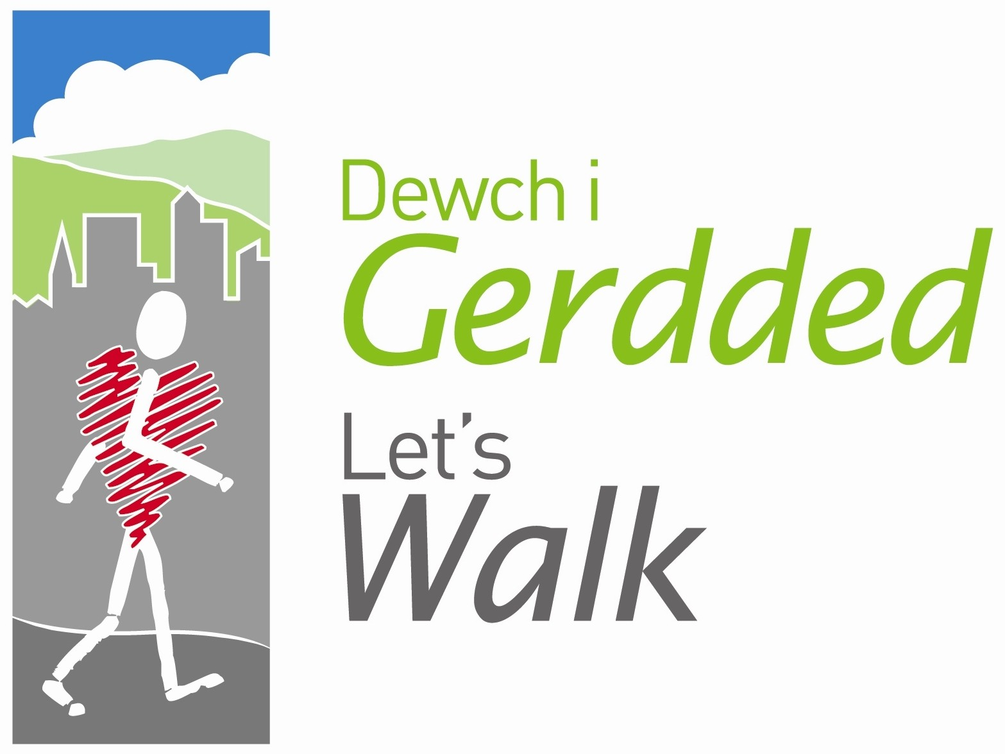


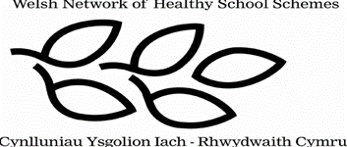

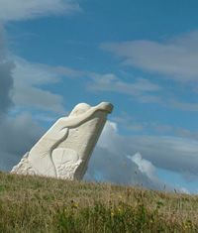

Peak Number 13:

Picnic Mountain

Height:
29m
Distance to summit:
800m
Time to summit:
10 minutes
Difficulty:
Easy, a short walk up to the summit if you walk to it directly but take your time and follow the surrounding paths walking around the base of the hill for a longer walk.
Directions:
Head towards Oswestry on the A483 and come off at the Rhostyllen junction, taking the first exit left and start heading towards Rhostyllen village. Turn right at the Lex Car and Van building, signposted Erddig/Bersham Enterprise Centre. Follow the road around the bends and keep going as the road turns into a country lane. At the junction, turn right back onto road and shortly you will approach the car park on the right.
Alternatively take the Plassey turn off from the A483 and head towards Johnstown. Take the first turn right for ‘Denis of Ruabon’ and the car park is further along the road on the left.
Parking:
WCBC Car park – free of charge.

The Area
Picnic Mountain, a large hill, is situated in Bonc yr Hafod Country Park and has spectacular views of Wrexham. Bonc yr Hafod covers 90 acres and is the former site of Hafod colliery tip, in fact, the sculpture at the top of the summit is surrounded by wooden carvings which point to different historical areas in Wrexham like a compass. Made in the form of a sundial, changing through time, the sculpture is a memorial to the miners of the area.

There are several ponds in the park, many are home to the endangered Great Crested newt and the woodland provides a home for skylarks who are threatened by extinction.
There are various routes and paths around the area and many people walk their dogs or even ride their horses around the area. All the paths interlink and this walk is circular whichever route you take and if you wanted to climb the summit straight away you could however for a sense of achievement, we recommend walking around the base and climbing up when you are ready to take in the breath taking views.
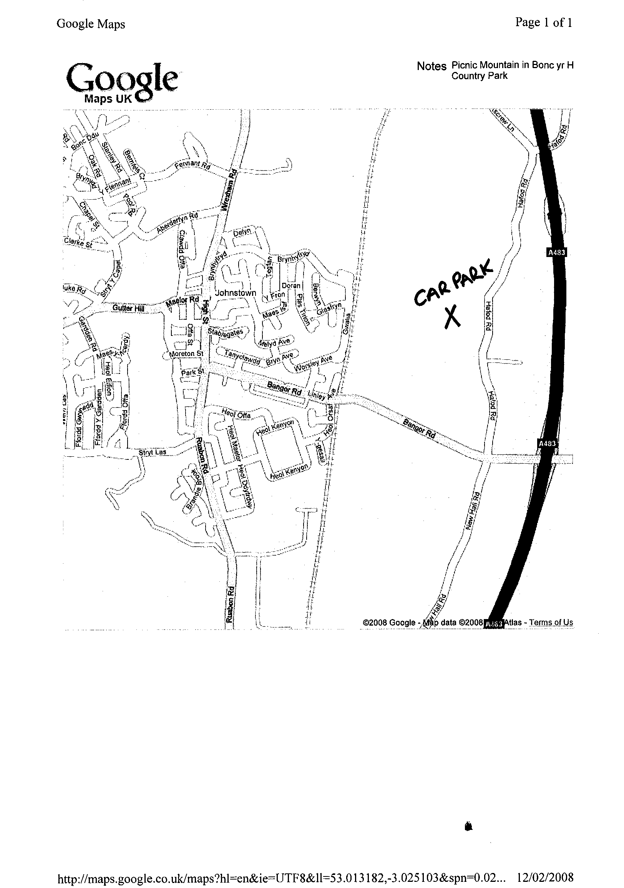

Directions for the Walk

- In the car park you will find a wooden map of the country park. Go through the kissing gate and climb the hill ignoring the path on the left. Shortly you will come to a fork in the road with the yellow footprint pointing to the path that goes downhill (alternative route), keep to the left and shortly on your left you will see path that climbs up the hill to the summit.

At the Summit
At the summit you will see a large white sculpture of a Miner; this is in commemoration of the Industrial era of Wrexham and in particular the mining communities. See if you can spot the wooden sculptures pointing towards Erddig Hall, Bersham Colliery and Wrexham Town Centre. Take your picture at this statue.

An Alternative Walk
Follow the yellow footprints or yellow walking man signs for the longest route around the area. It maybe muddy in parts and there will be shallow streams running along side the path at points. You will also be walking on a path which runs parallel to a train line; maybe if you are lucky you will see a train! You will have plenty of opportunity to go onto different paths without ever getting lost so feel free to explore!

Refreshment
There are picnic tables at the summit away from the statue so take a packed lunch or alternatively get back in the car and stop off at the Little Chef at the bypass roundabout or head into Wrexham town centre.

