
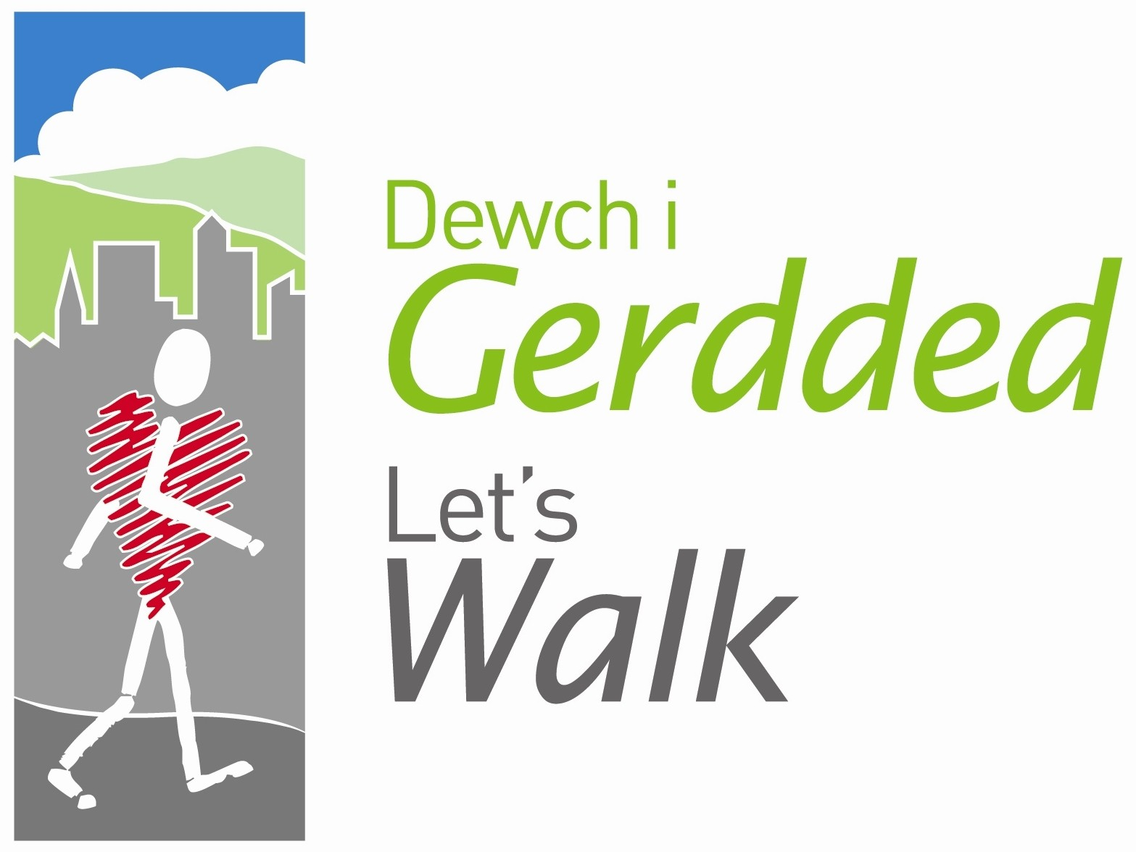



Peak Number 14
Minera (Esclusham) Mountain

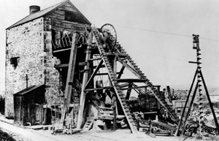
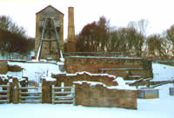

Pictures of Meadow Shaft Engine House taken from WCBC Website

Height:
The Mountain is 456 metres high (1496 feet)
Distance to summit:
4.6km (2.85 miles) to Summit climbing 1461 feet.
Time to summit:
Allow for 1 hour 45 minutes but can take longer on wet, windy days.
Difficulty:
Moderate to Hard. 4 mile circular walk with steep, steady inclines and in some parts it can be very muddy. There are some stiles that dogs would have to be carried over.
Directions:
Head through Coedpoeth and as you leave the village, with the pub ‘The Five Crosses’ on right, at junction turn left towards Minera and follow signposts to Minera Lead Mines Country Park.
Parking:
The WCBC Car Park at Minera Lead Mines (free) is located on Wern Road, Minera, LL11 3DU next to the villages of New Brighton and Minera. It can be reached from the A483, signposted as "Clywedog" on the A483 and "Minera Lead Mines" on the A525.

The Area
People have mined for metals at Minera since at least the Middle Ages (the English name Minera comes from the mediaeval Latin for mine or ore). The first written reference to mining at Minera dates from 1296 when miners from Minera were sent to Devon by Edward I to work his silver mines. Edward I was as usual short of money so needed silver to mint coins. Mining at Minera was often problematic: Black Death stopped work as there was a labour shortage, Owain Glyndwr scared off the English mine owners at the start of the 15th Century.

In the 1780s John Wilkinson's steam pumping engines made expansion of mining at Minera possible but flooding always remained a big problem. Lead mining reached its peak at Minera in 1863-4 when 6822 tons of Lead ore and 1179 tons of Zinc ore were mined. Profits were just under £70,000 for that year - an extremely tidy sum. Yet by 1890s the price for lead ore had collapsed, in 1910 the pumping machinery was sold and the mine closed in 1914.

During 1990-2 the site was excavated and the remains of the lead processing works restored or stabilised. These are just the bare facts from the history of the lead mines. To learn about what life was like there for the people who worked there on the surface or down below, you need to visit the site.

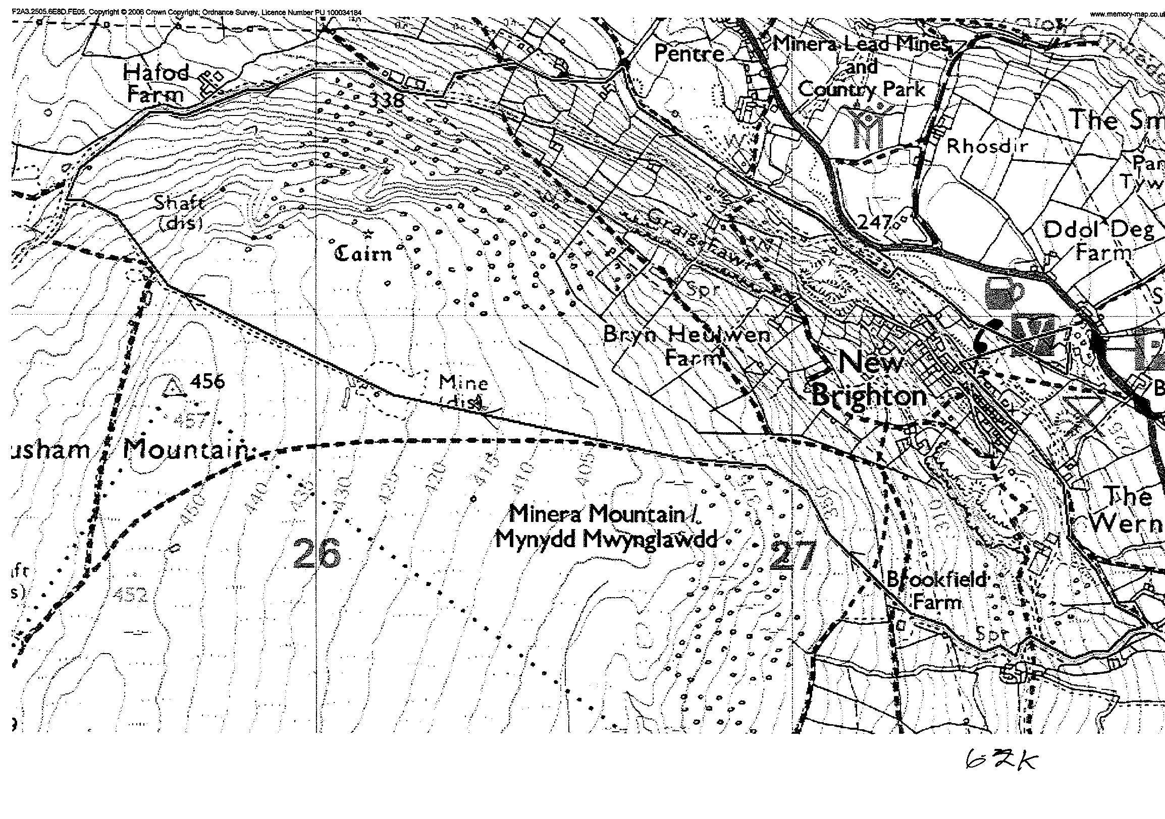

Directions for the Walk

- Follow path from car park, behind notice board, which goes up and bends round to the right, turn right at sign post ‘Taylors Shaft’ and follow path towards the historic Meadow Shaft Engine House.
- Turn left at the little post with the arrow pointing upwards, following path cut into the woodland. Follow path through trees go straight over, past the bench and up the steps.
- At top of steps, go through a kissing gate and turn left, follow path past houses until you reach a stile (dogs can go under the metal gate), go over and about 20 metres on, you approach a crossing over a stream. Look right and see a hidden tunnel in the hillside. Follow path straight on but watch out, it gets very muddy!
- Path splits into grassy path on left and uphill to the right, stay to the left following stone mossy wall (if you do go uphill by mistake you will come to a large mound of earth, if you clamber over, it will eventually join path further along).
- Following the wall you will come to a great view point between a clearing of the trees which shows views of the back of Coedpoeth, Minera and the surrounding villages.
- Go over the next stile, be careful if you have a dog as there is a vandalised barbed wire fence although has plenty of space, can be dangerous for a dog.
- Where path forks, carry on straight forward (if you do turn up hill or took the uphill path earlier by mistake, you will come out at the top of this path), follow natural grass path way passing stone house on left. Go over stile (dogs will have to be carried over this stile) and turn immediate right following tarmac road as it climbs steadily up – this is a steep climb, take plenty of rests if you need it.
- Continue on path, pass a stone house being renovated on left, keep climbing until you reach house at top of the path. Turn around and view the spectacular scenery.
- Enter field next door by following the footpath sign and going through the metal gate. Make sure this is closed securely as cattle sometimes graze in the field.
- Head up to the fence at the back of the field, go over stile (dogs will need to be lifted as it is quite high) in the middle of the field into open landscape full of bracken and heath.
- Follow grass trodden path, at fork, turn right (VERY IMPORTANT) and follow grass path, you will shortly walk over a wooden crossing over a stream. Follow path as it climbs, which becomes very muddy but once you reach the point where the inclines relax, the view points across the Wrexham area are amazing.
- The path will widen out and eventually you will come to a flat wide area with mounds of gravel, sand and mud in view, follow and walk straight up and over. Quad bikes have been seen in this area so be alert. There are various signs of bomb craters caused by German Bombers in the Second World War who confused Minera for Liverpool.
- Once you have passed over the gravel site, the path soon becomes surrounded by heath again, continue onwards and shortly on the left hand side you should see the turret shaped Trig Point about 200m away. You can reach it by going cross country or continue on the path until there is a left turning which you can follow to the trig point. WELL DONE!!! You have reached your summit! The Panaromic view includes Moel Famau, the Ponderosa the Cheshire Plain and Wrexham. Take your picture here.
- Return to the main path and follow downhill (further bomb craters will be seen on the way down) until you reach the main tarmac road, turn right and follow straight back to the Visitors Centre.
- You will pass over a cattle grid (there is a gate that can be opened). Further along the road you will see an excavated ruins of building which used to be a cemetery. As you pass this on the left and house on the right, you will see a green sign for ‘Minera Lead Mines Country Park’. Cross over to the right and follow path which winds between trees. The path runs alongside a main road, when you reach the yellow salt/grit box where path ends, you will have to cross over road and continue on path which winds back to main lane.
- When the path opens up you should be able to see the chimney pot and the engine house, turn left, go down hill and turn right. Follow gravel path and follow, sticking to the left, to the engine house you turned left at, at the start of the walk. The car park is shortly on your left hand side.

At the summit
The Trig Point has an engraving of the OS Map reference, can you see it? What does it say?

Refreshment
There aren’t any points along the walk before the summit which are picnic areas, once you start the climb down, there are large open, green areas which you could have a picnic at. However if you would rather not carry food and drink up Minera Mountain, treat yourself for a meal in the nearby Tyn-y-Capel Restaurant. To get there, follow the road back but turn left at junction to Minera, then right at the telephone kiosk - the Tyn - Y- Capel can be found at the top of the hill on the left hand side, opposite St. Mary's Church, Minera.

The Visitors Centre
Open;
March 29th - April 16th, May 4th - 7th, May 24th - June 4th and July 20th - September 3rd
Open Thurs, Fri, Sat, Sun & Mon. 12noon - 4.30pm
Also open weekends only between June 9th - July 15th
Group visits by appointment all year round

For more information follow this link;
www.wrexham.gov.uk/english/heritage/minera_visitors.htm

