
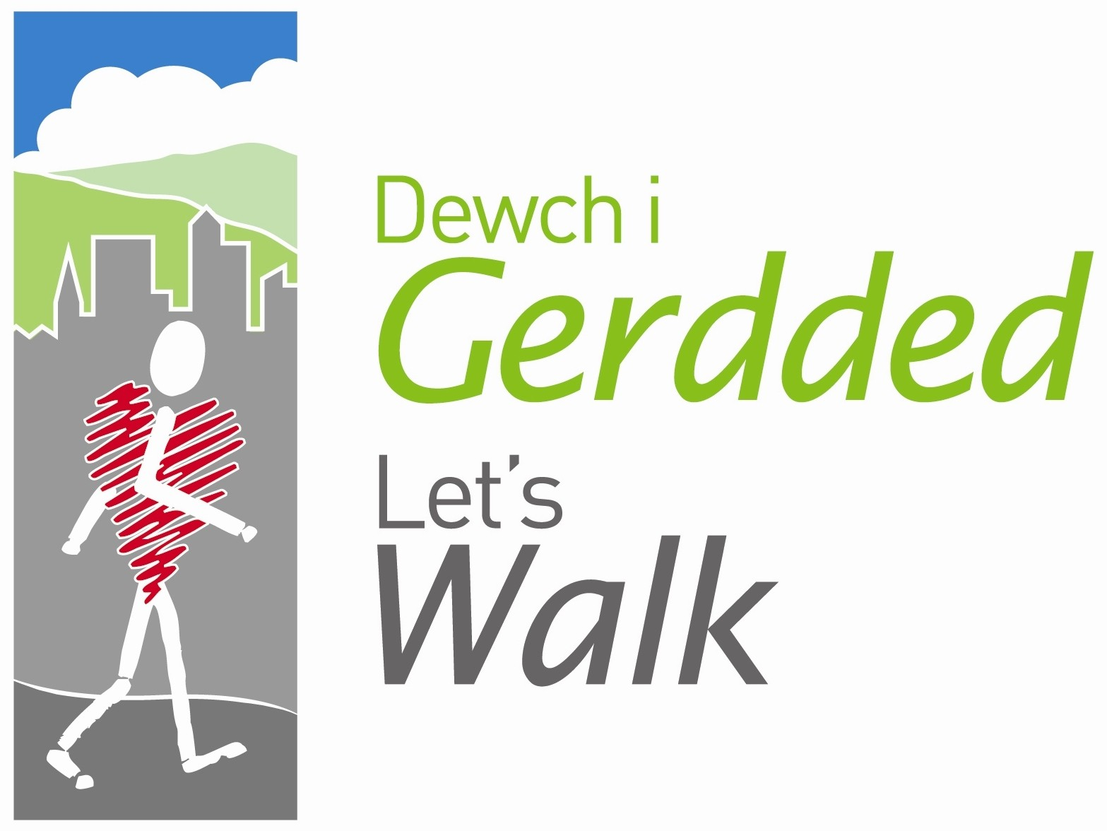




Peak Number 15:

Horseshoe Falls & the Velvet Hill
Height:
260m
Distance to summit:
4 miles
Time to summit:
1 hour 45 minutes
Difficulty:
Moderate. There are rolling hillsides, woodlands and riverside pastures and 7 stiles. Dogs need to be on leads.
Directions:
From Wrexham take A483 towards Chirk coming off at junction sign posted ‘Plas Madoc Leisure Centre’. At roundabout take 3rd exit onto A539 under road bridge then immediately take 1st exit. At next roundabout take 2nd exit onto A539 sign posted Llangollen. Head towards Horseshoe Pass, after approx 1 mile turn left by Chain Bridge Hotel to Llantysilio.
Parking:
Picnic site and car park at Llantysilio Green on minor road north of Berwyn Station, public toilets are available here too. Toilets available in the summer.
Map:
OS Explorer 255 Llangollen & Berwyn

The Area
The Horseshoe Falls is a picturesque semi-circular weir designed by the famous engineer Thomas Telford in 1806 to supply water to the Shropshire Union Canal. However, the canal took so much water from the river Dee that many of the local mills were forced out of business.
Llantysilio Church occupies high ground just north of the Horseshoe Falls. Originally a small chapel built around 1254; the church was thoroughly restored by the Victorians in 1869. Inside are a rare medieval oak eagle lectern and two small 15th-century stained glass figures incorporated into the later North window.
Velvet Hill gets its name from the soft texture of the sheep cropped grass and moss. Its Welsh name, Coed Hyrddyn, means ‘wood of the long man’ and may relate to the tall skeleton unearthed beneath nearby Eliseg’s Pillar.
At Llangollen Station, you can take a ride on one of the vintage steam trains that travel along an 8 mile stretch of the Dee Valley to Carrog. Thomas the Tank Engine is a regular at this station and a favourite with young children.

Directions for the Walk

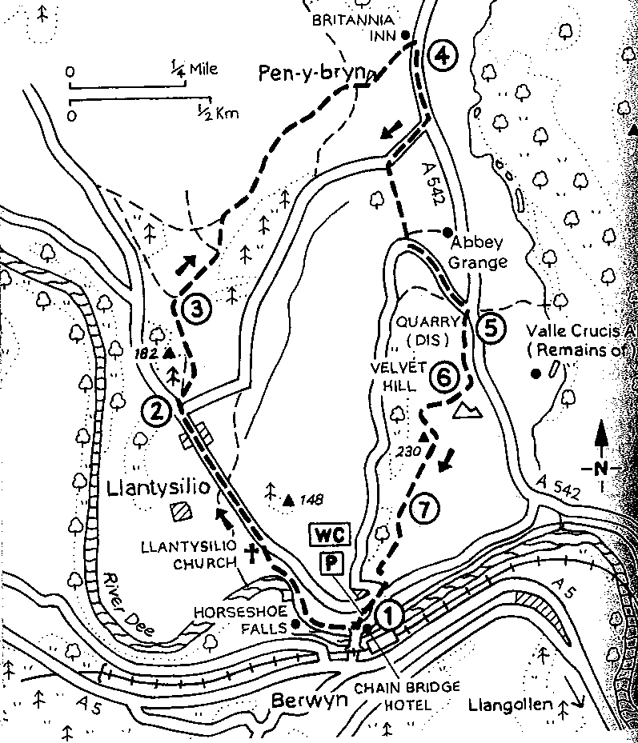
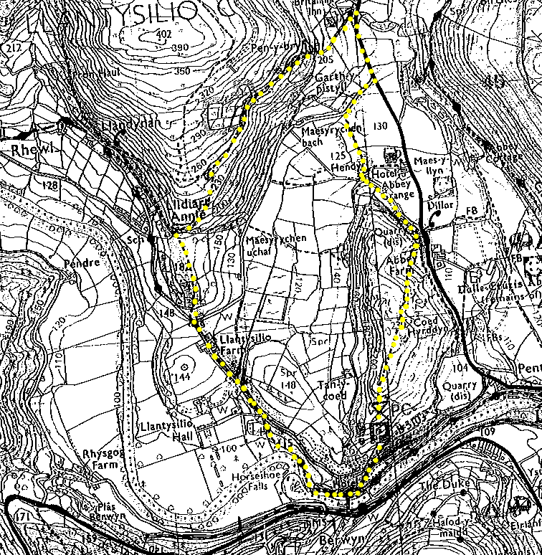

- From the car park, walk down to the road, turn right for a few paces then descend down some steps to the back of the Chain Bridge Hotel. Turn right to follow the path between the river and canal.
- Through a kissing gate at the end of the canal, you go across riverside fields past the Horseshoe Falls and climb to Llantysilio church.
- On reaching the road, turn left through the hamlet of Llantysilio to reach a junction. A few paces along the side road, cross stile next to gate (entrance to field can be very muddy). Go along rutted track with forest to the left, which climbs north onto a hillside.
- Through a gateway at the top of the field, the path swings right. The now narrowed path descends to a complex of cottages at Pen-y-bryn. After squeezing through a ginnel (narrow gap) to the right of the first cottage, the route follows a tarmac drive out to the Horseshoe Pass road at the Britannia Inn.
- Turn right along the road, then right again after about 200 yards when you get to the first junction. Go over a stile on the left to head south across three fields. Turn right along a farm track then left past a large stone-built house to arrive at a narrow lane. Go left along this to meet the Horseshoe Pass road again.
- Go over a stile on the right-hand side of the road, signposted to the Velvet Hill and ascend by quarry workings.
- Turn right along a wide grassy track climbing steeply through the bracken to reach the ridge, where you turn left for the summit. Well done you have reached the summit!
- Descend south on a narrow footpath to reach a fence above some woods. Do not cross (as many have done) but follow the fence down left to a stile. Across the stile go right, along a path that leads back to the car park.

At the summit
On Velvet Hill (a flat plateau with a 360 degree view) you can see the Cistercian abbey of Valle Crucis and the castle topped hill of Dinas Bran. You should also be able to see the River Dee below and where it is joined by the Afon Eglwyseg.

Refreshment
The Britannia Inn, along the route, serves Theakston’s ales and a good selection of bar meals. There is a wide selection of cafes and pubs to have a meal in Llangollen and a variety of ideal picnic places.

