
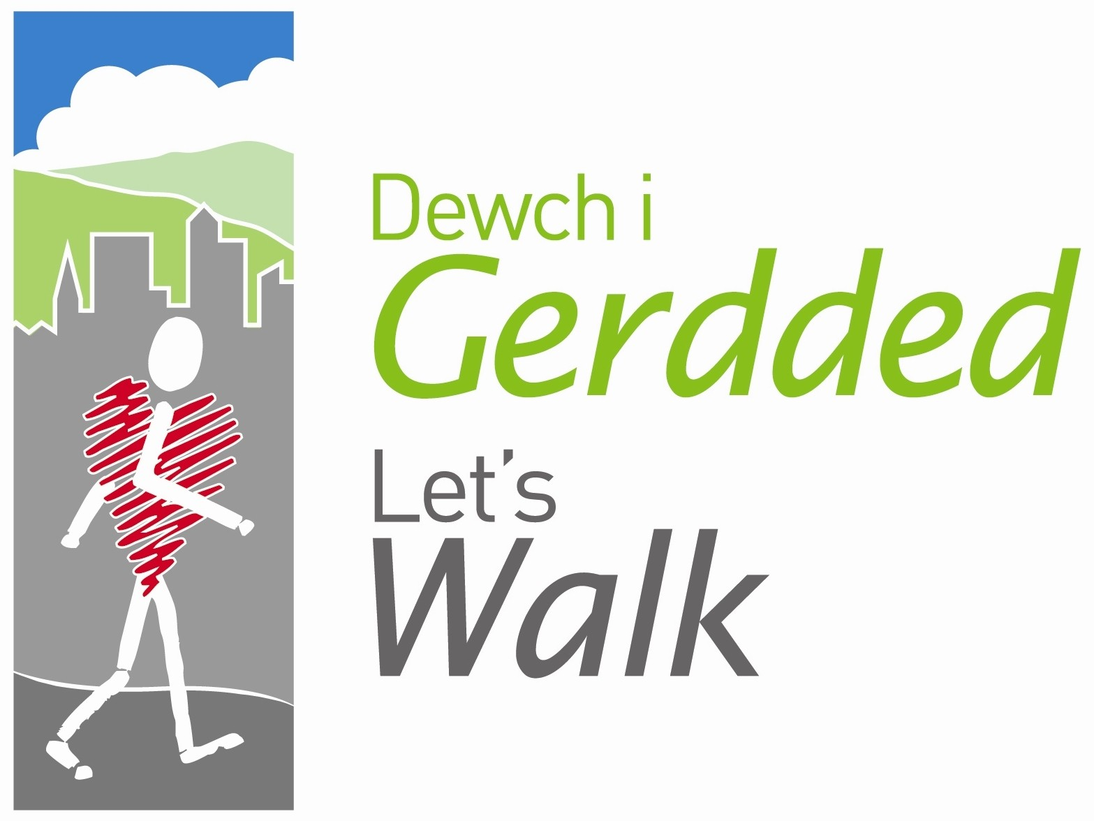




Peak Number 2:
Castell Dinas Brân

Height:
320m
Distance to summit:
1 ¼ miles
Time to summit:
¾ hour
Difficulty:
Moderate. The climb out of the town is a little steep, but the summit is reached via a zig zag path which is relatively easy.
Directions:
From Wrexham take A483 towards Chirk coming off at junction signposted ‘Plas Madoc Leisure Centre’. At roundabout take 3rd exit onto A539 under road bridge then immediately take 1st exit. At next roundabout take 2nd exit onto A539 signposted Llangollen.
Parking:
Llangollen Riverside Car Park (long stay). Grid Ref. SJ217421. Arriving in Llangollen from Wrexham, the car park is on the left, about 200m before Llangollen bridge (and just before the Ponsonby Arms). 80p in change will be needed for 4 hours parking (this price may have altered)

The Area
The fortress of Castell Dinas Brân was built around 1260 by the Welsh prince Gruffydd ap Madoc – and it was destined to have a very short life. Just twelve years later Edward I became King of England and began attacking the borderland to make sure the Welsh could not gain the independence they wanted. To prevent Dinas Brân being captured and used by Edward’s troops, in 1277 the Welsh owners of the castle burnt it down themselves. Nevertheless, an English garrison set up camp in the ruins and from there kept watch over the Dee valley. Five years later the troops had left and Dinas Brân was given to the Earl of Surrey – but he didn’t fancy living in such an exposed spot and built his own new castle beside the River Dee at Holt. You can visit the ruins of that castle too – but there’s much more to see at Dinas Brân!

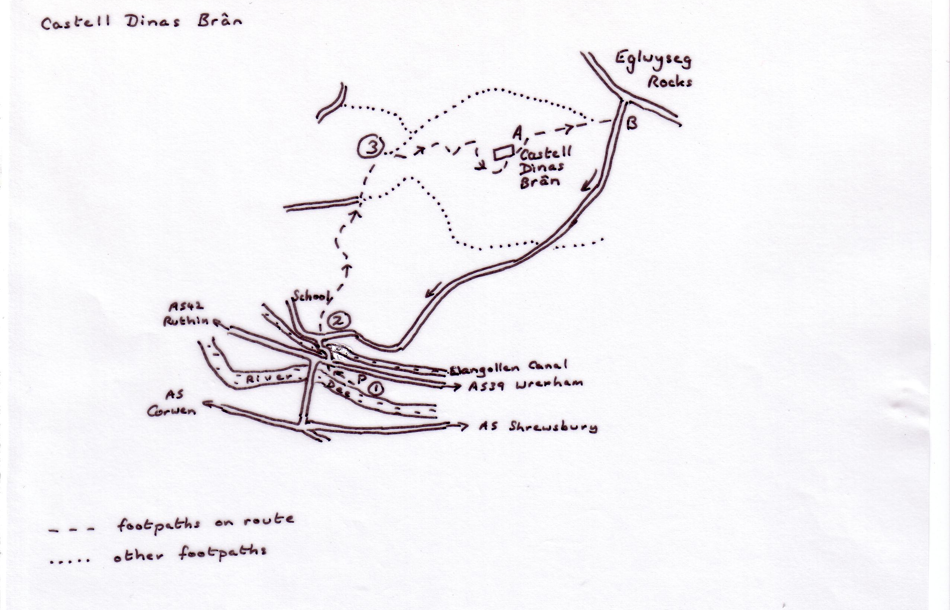

Directions for the Walk

- From the car park, walk along the riverside path and come up the steps beside the bridge. Cross the Wrexham road and take the uphill road on the opposite side (taxidermists on the corner).
- At the canal bridge, take the narrow path directly opposite, alongside the school – it is signed to ‘Offa’s Dyke Path ’. This rather steep hard-surfaced path continues along the side of a grassy slope and finally emerges on a track. Keep straight ahead on this, crossing directly over the four-way junction to reach the mountain gate
- Ignore the path on the left and climb straight ahead. Cross the grassy plateau (called the ‘pancake’ by locals), go down the dip and then up the other side to pick up the obvious stony track that winds to the summit.

At the Summit
Take your picture at the castle. Look at the castle; the passage-way and the keep on the far side are the best preserved parts. The two joined arches on the side overlooking the town are said to be the ‘dining-room windows’. Can you imagine having your dinner with such a view? To the right of the windows there was a D-shaped tower – you can just see its shape on the ground

Now its time to take in the view. On the opposite side from Llangollen, the white rocky limestone ridges of the Eglwysegs rise even higher than Dinas Brân. Behind them is Ruabon Mountain, another of our ‘Nine Peaks’. Next look down the river valley towards the distant flat farmland of Shropshire. You can see two roads, the river, the canal and the track-bed of the old railway, all running together through the valley. Can you see the arches of the viaduct at Newbridge that carries the railway over the River Dee? And can you see the new A483 road bridge that carries the road over the Dee immediately behind? You can’t see Telford’s famous canal aqueduct because it is tucked behind the high ground of Trevor Rocks on your left.

Next walk to the other side of the summit (the side where you first arrived). This side has the best view of Llangollen - the new Eisteddfod pavilion looks like a big white beetle in the middle of it all. Now look up the Dee valley into Wales. The big cone-shaped mountain far away up the valley is Foel Goch (near Llangwm), a mountain sacred to the gypsies, and the flatter ones on the right and farther back are the mountains north of Bala.

An Alternative Way Down
A Walk over to the ‘English’ side of the summit and take the
path around the right hand side of the ditch (some of the stone for the castle was dug out of this ditch). Soon you can see a gate in the fence at the bottom of the hill, and you simply walk down to it.
B Go through the gate and turn right on the rough road. Just
keep ahead on this and you will find yourself back at the
canal bridge in about ½ an hour.

Refreshment
There are plenty of pubs and cafés in Llangollen!

