
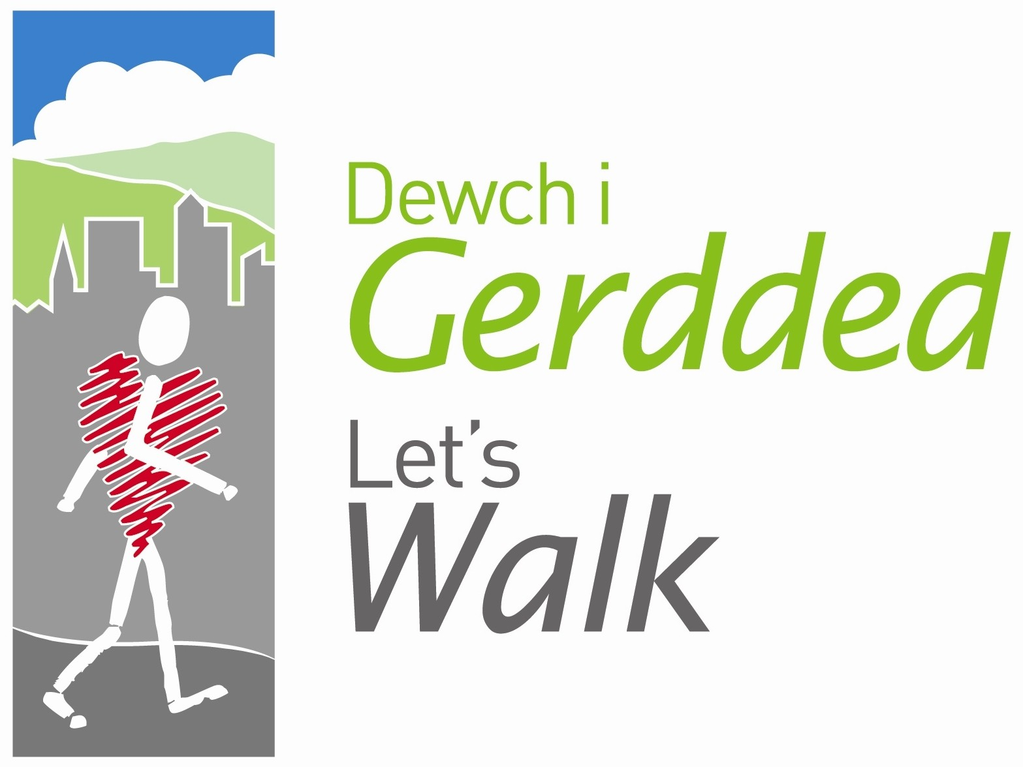


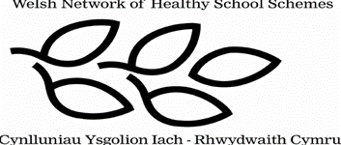

Peak Number 3:
Cyrn-y-Brain

Height:
565m
Distance to summit:
1 ¼ miles
Time to summit:
40 minutes and a further 20 minutes to Sir Watkin’s Tower
Difficulty:
Easy to Moderate. A hard-surfaced track takes you all the way, climbing fairly steadily. There is a short steeper section just before the summit.
Parking:
From Llangollen, take the A542 to the top of the Horse Shoe Pass, and park at the Ponderosa café or on grassy bank opposite (Grid Ref. 193 481).

The Area
Cyrn-y-Brain is one of the highest of the ‘Nine Peaks’, but you don’t have to work too hard to get there because the mountain stands right beside the Horse Shoe Pass, which itself rises to 417m. On the mountain top are the masts of a radio transmitting station belonging to British Telecom, used by Ambulance Services and others who need long-distance radio communication. Long, long before the masts were installed, local landowner Sir Watkin built himself a stone tower on this summit, at a spot where he could look out with pride across the seven counties in which he owned property. It’s only a heap of stones today, but the view is the same and it gives you that on top of the world feeling – up here you have everything from Snowdonia to the Peak District to the Midlands under your gaze.

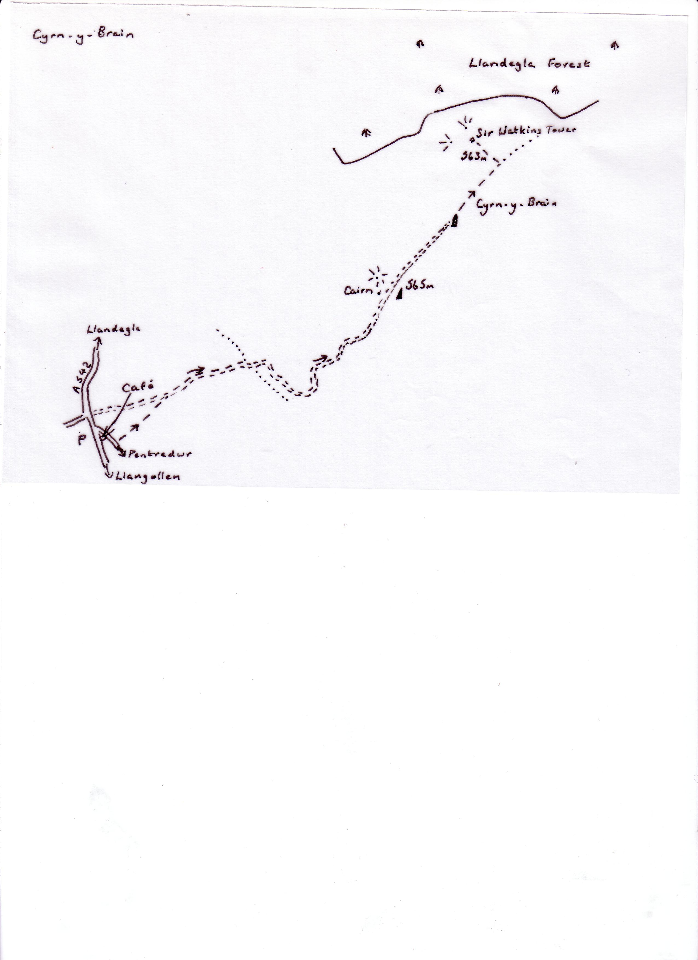

Sketch Map

Directions for the Walk

- From the back of the Ponderosa car park, cross the narrow road (from Pentredwr) and climb the stile in the fence opposite. Walk uphill alongside another fence to reach the gravelled track. Now you can go on automatic pilot – simply follow this winding track to the cairn near the transmitting station, which marks the summit
- To find Sir Watkin’s Tower from here, continue on the track to the second radio installation and then keep ahead for another similar distance until you reach a new signpost and a stile in the fence on the left. Over this stile, a path through the heather takes you past a trig. height (563m here) to a mound of stones overgrown with grass, all that remains of Sir Watkin’s Tower

At the Summit
The cairn is a circular stone shelter – get inside to protect yourself from the breeze (or maybe howling gale) and take your picture here. Why not look around there is so much to see! Start with the nearest mountain, Moel Gamelin, which rises on the opposite side of the road from the Ponderosa. To the left of Gamelin are the sharp edges of the two Berwyns, Cadair Berwyn and Cadair Bronwen. To the right of Gamelin, the irregular shapes are those of the Arenigs, with between them and nearer to you, the conical Foel Goch. To the right of these, the huge mountains farther away are Snowdonia – and right again are the closer Clwydians. Then it’s the estuaries of the Dee and the Mersey (best seen from Sir Watkin’s Tower), and clockwise from here, the Peak District lifts the horizon. Farther round still, the flat plains of Cheshire are broken by the line of the Peckforton Hills, the rounded bulk of the Wrekin and the Long Mynd. With a map and compass there’s a lot more to identify – just take your time.

An Alternative Way Down?
Unless you are a very good map-reader there simply isn’t one. One possibility is to follow the forest edge down to the west and then pick up the path through the heather heading south – but it’s a long way round. The map you would need is OS Explorer 256

Refreshment
The Ponderosa café is open all year round

