
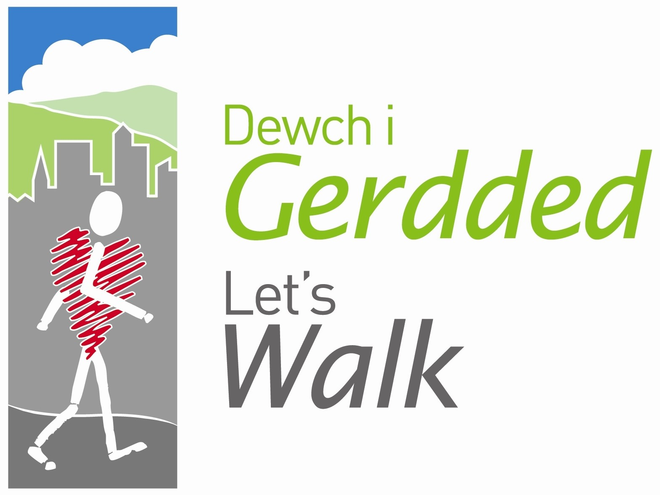

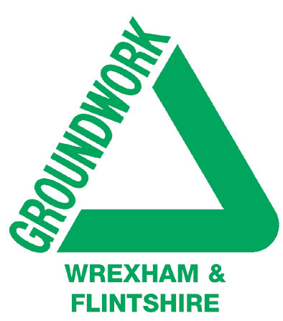


Peak Number 4:
Moel Famau

Height:
554m
Distance to summit:
1 ¾ miles
Time to summit:
45 minutes
Difficulty:
Moderate - a steady but gentle climb on a good track. The short section immediately before the summit is steeper.
Directions:
From Wrexham take the A541 signposted Mold after 10 miles, at large roundabout take first exit onto the A494 and follow this road through towns of Gwernymynydd and Loggerheads, until you come to a junction with `Moel Famau Country Park` sign posted to the right.
Parking:
At the car park for Moel Famau Country Park (Grid Ref. SJ 161605). There are actually two car parks beside a minor road running round the foot of the mountain. This road can be accessed from the A494 Mold to Ruthin road – from Mold, turn right about half a mile after Loggerheads; from Ruthin, turn left after a sharp right hand bend just beyond Llanbedr-Dyffryn-Clwyd and at the T-junction, go right. The car park you want is the western one, the one nearer to Ruthin.

The Area
Moel Famau is the highest point of the Clwydian chain. Its name, meaning ‘Mother Mountain’, possibly refers to its profile, which could be thought to resemble a breast. In 1810 a pyramid was erected on the summit to commemorate the Golden Jubilee of George III, but it was never finished and was finally destroyed by a storm in 1862. It was somewhat restored in 1970, when four panels were installed pointing out the distant features in each direction – and the view extends from Liverpool to Cader Idris!

The land on the slopes of Moel Famau has now been given the status of a Country Park, managed by Denbighshire Countryside Services. You will see that there are many clear footpaths, both on the open moorland and in the Clwyd Forest on the eastern flank. If you want to create your own interesting walk within the confines of the Park, you could pick up a leaflet with all the details from Loggerheads Country Park a couple of miles to the east.
Note that the path you are following here is actually a small part of the Offa’s Dyke Path which runs from Chepstow to Prestatyn, a distance of 177 miles. If you are tempted (and you should be), remember it isn’t all as easy under foot as this section!

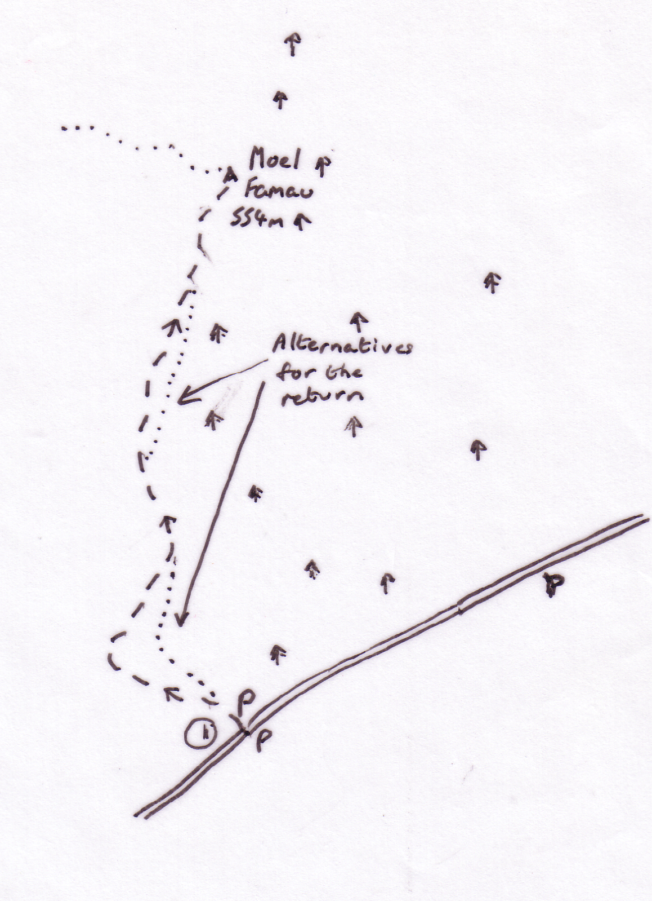

Directions for the Walk

- It couldn’t be easier – just follow the signs from the car park pointing to the Jubilee Tower and a broad gravelled track will take you all the way. Right at the beginning (a few yards from the car park) you will see a prominent path branching off uphill on the right. This is simply a ‘short cut’ – take it if you like, or reserve it as a variation for the return.

At the Summit
Go up the steps into the remains of the tower and look all around you! The toposcopes are very helpful in pointing out the most interesting things to look for. You can clearly see the estuaries of the Dee and the Mersey, and with binoculars you should be able to pick out the Liver Building and the Anglican Cathedral in Liverpool. Swing round and look at Snowdonia – Snowdon is there, along with Tryfan and the Carneddau. Continuing in an anticlockwise direction you reach the Arans and behind them, Cader Idris. Then it’s the Berwyns and the nearer Gamelin and Cyrn-y-Brain cutting off your view. Take your time – just enjoy it all and don’t forget to take your picture here!

An Alternative Way Down
A simple alternative is to descend on the main track to the end of the inlaid slate slabs (the steeper bit) and then take the quieter track on the left beside the fence. A little farther along, you could cross the stile in the fence and follow the prominent track on the opposite side. Eventually this bends away, and you can cross another stile to regain the main track. A little farther along, where the track swings right, take the grassy track over the flank of the hill on the left – it is a short cut to the car park.

Refreshment
There’s none on the site. But if you are in this area, it’s worth visiting Loggerheads Country Park (about 3 miles to the east on the A494) where there is a café and lots of visitor information. There are some excellent walks around Loggerheads - you’ll surely want to return.

