
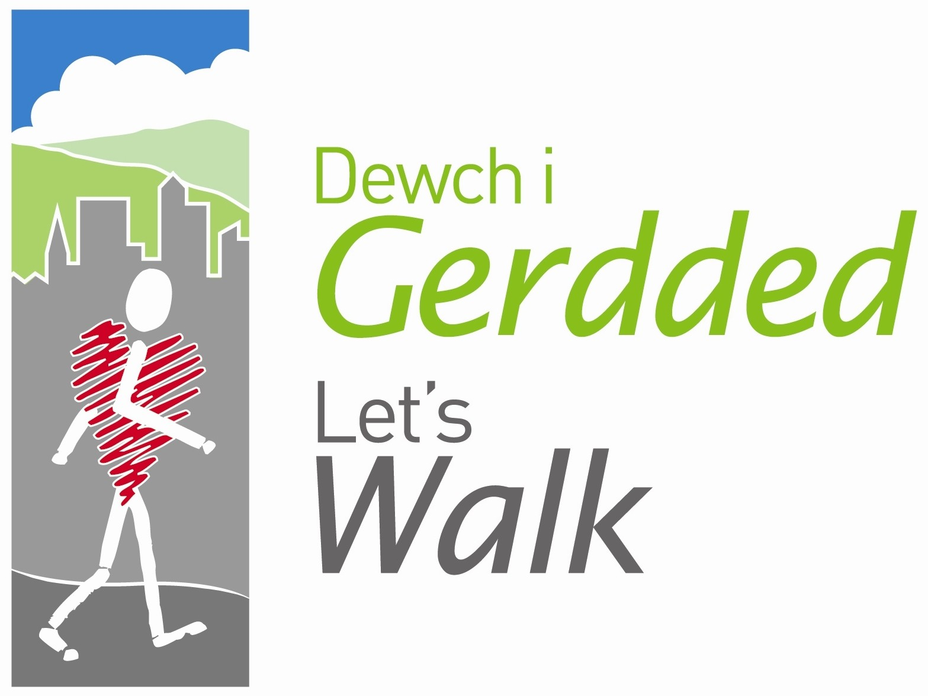

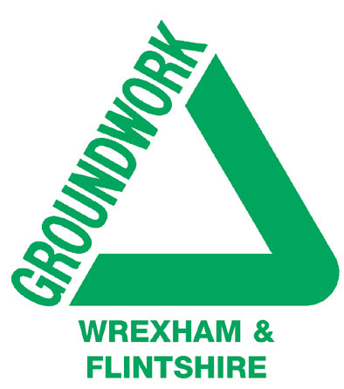
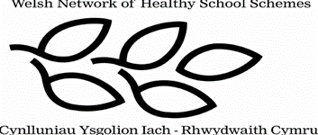

Peak Number 5:
Moel Fferna

Height:
630m.
Distance to summit:
3 miles
Time to summit:
1 ¾ hours
Difficulty:
Moderate - starting from near the river, the total ascent here is a grand 500m – but it is evenly spread and nowhere is the gradient too steep. Tracks are well-defined, both in the forest where there are good waymarks, and later on the mountainside.
Directions:
To reach Carrog, head west from Llangollen on the A5 for about 7 miles, and then turn right in the village of Llidiart-y-Parc.
Parking:
The railway station at Carrog (Grid Ref. SJ 117435) offers parking for customers – and you might consider stopping for a cup of tea on your return, or even taking a train ride to complete your day. Otherwise, it is possible to park on the roadside just before the river bridge in Carrog.

The Area
Moel Fferna is by far one of the loftiest of our ‘Mini Mountains’. Its height of 630m would in old terms be 2046 ft., and so it has the distinction of being included in the list of Welsh ‘Hewitts’ – mountains over 2000 feet. There are apparently just 137 of these, and after conquering Fferna, you might consider tackling the rest some time!

In reality, Fferna is quite a gentle mountain and you should not be too out of breath to enjoy its wild moorland setting and some really magnificent views. As you approach the summit you will also get glimpses of the slate quarries to the left of your path. These were part of an extensive network along the valley of a stream known as Nant-y-Pandy, and were in use until the 1950s.

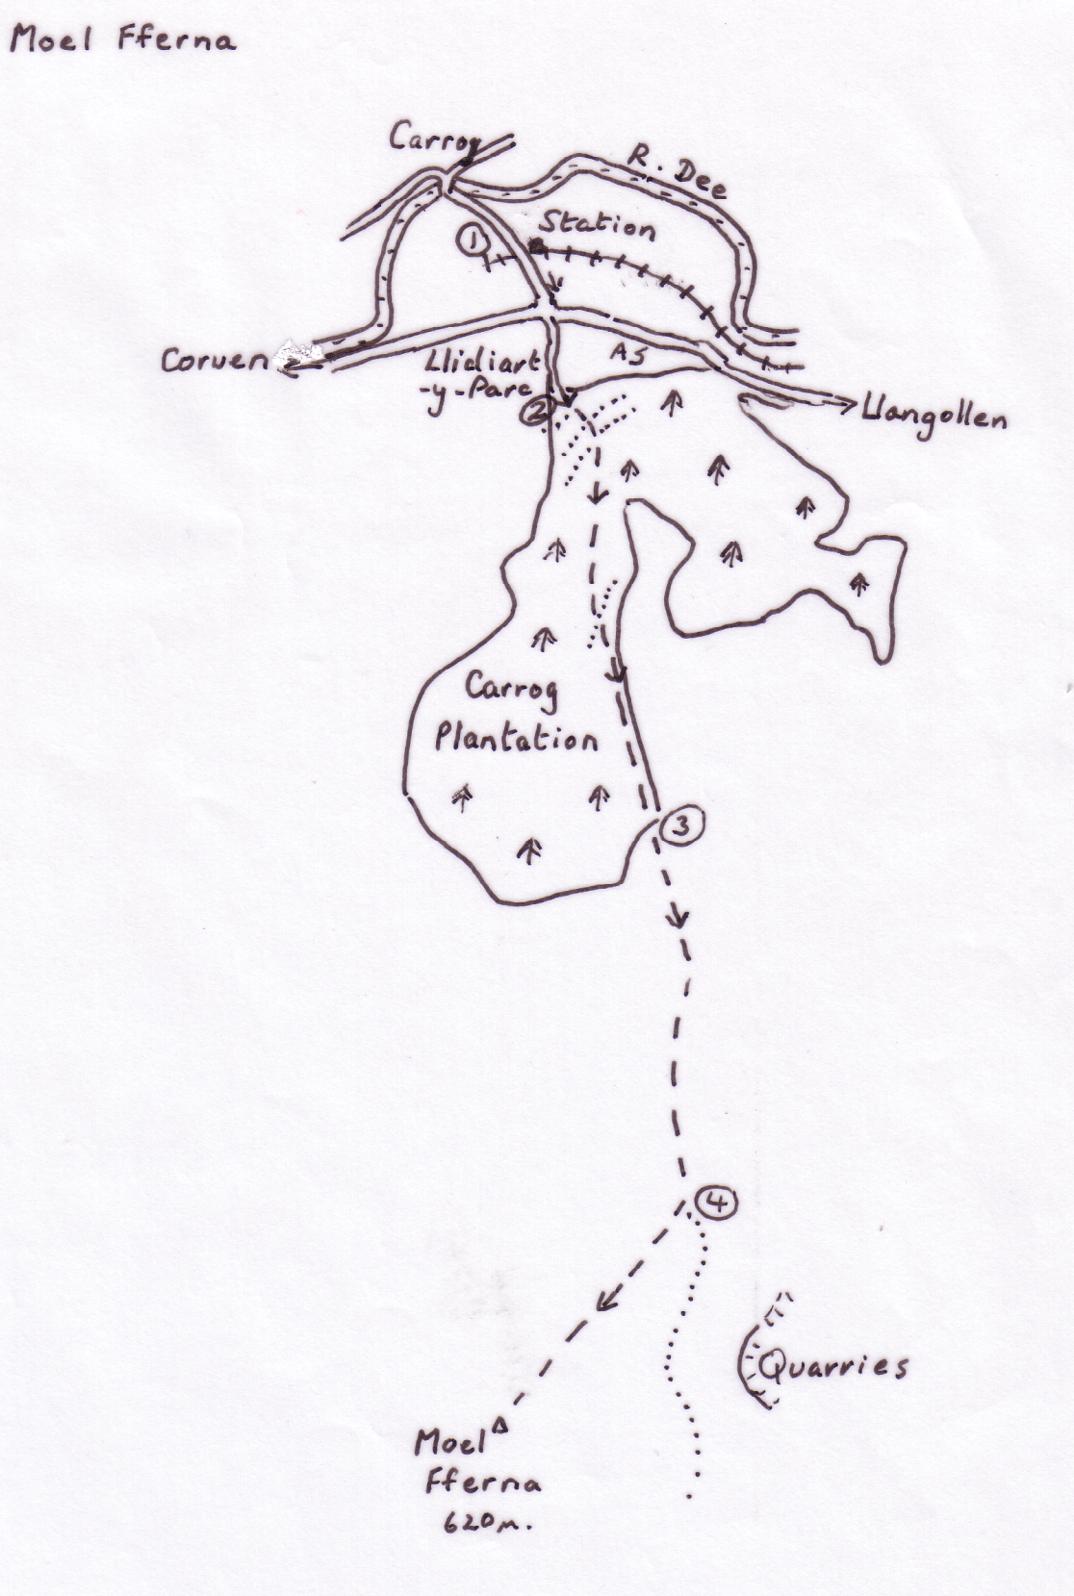

Directions for the Walk

- From the station, walk up the road to the A5 and cross it with care. Continue up the road immediately opposite, which soon becomes a Forestry Commission track heading into Carrog Plantation
- At a fork, the forest track bears away to the right, but you follow instead the earthen track climbing uphill to the left – there is a prominent yellow arrow to show you the way. Reaching another forest road, you turn right briefly and then again follow the arrow up the bank on the left to reach yet another forest road. Again the arrows direct you right and then immediately left uphill through the pine forest, with the land falling away to the valley of a stream on the right. Eventually the scene opens out where the trees on the right have been cut down. Keep climbing on this broad track, ignoring any lesser tracks off it. At length you reach another gravelled forest road and the yellow arrows are there again to take you diagonally across it. The track soon reaches the forest edge, and not long afterwards, a gate takes you on to the mountain.
- At this point you can see the summit of Fferna ahead and a little to the right. Two broad grassy tracks cut through the ferns and heather on the ground before you. Take the right hand one, which immediately bends round and heads for the dip on the left of the mountain. Keep with this track, climbing all the way and soon you can see a track leading up the side of Fferna to its summit (not the narrow track that has been in view for a long time). Suddenly the view opens up to the left and ahead of you.
- Now turn off right and take the rutted track to the summit – it doesn’t look quite so obvious at this point being a little overgrown with heather, but it gets clearer as you go. After a final sharp rise you reach the cairn with its fantastic views.

At the Summit
The circular cairn offers good shelter while you take in the scene, have your picture taken and perhaps enjoy a picnic. The most striking feature of the landscape is the nearby mass of the Berwyns (straight ahead from the path on which you arrived). The highest point here is a mighty 200m above the summit of Fferna. Turn your back on the Berwyns and the land dips away into the Dee valley – your eye can follow it to the east, but Llangollen is just out of view around the corner. Immediately behind the Dee valley you can see two peaks you may have already climbed – Moel Morfydd, with its broad summit track leading on to Gamelin, and farther along in the same direction, Cyrn-y-Brain distinguished by its radio masts. Farther back still the Clwydians stand in line and they don’t look so impressive from here. Even the highest of them (Moel Famau) is more than 75m below you. Turning in an anti-clockwise direction, your eye falls upon the mass of Snowdonia and if the day is clear you may be able to pick out Snowdon itself (at approx. 290° if you have a compass). Anticlockwise again, and the much nearer sharp-edged hump is that of Arenig.

Finally look to the left of the Berwyns, where just peeping behind the edge of a much nearer mountain, you can see the classically steep profile the Breidden Hills near Welshpool – one of them, Rodney’s Pillar, is included in our ‘Nine Peaks’.

An Alternative Way Down
There are several other ways down Fferna, but you need to be a fairly competent map-reader to take advantage of them. The simplest alternative is to follow the fence (you can see it from the cairn) east until you reach the broad track that leads down to Glynceiriog – but it’s a very long detour. It’s easiest just to go back the way you came!

Refreshment
The station café serves light snacks and ice-cream. For more substantial meals, you could head for the Grouse Inn, just across the river bridge in Carrog.

