
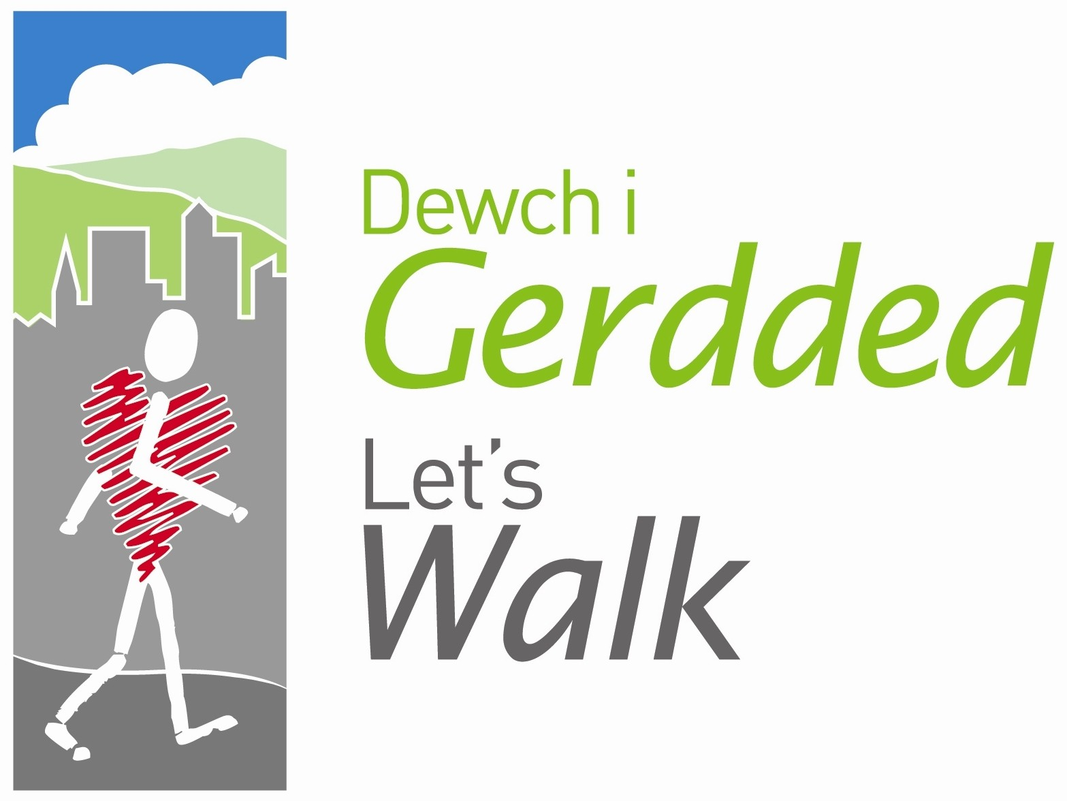

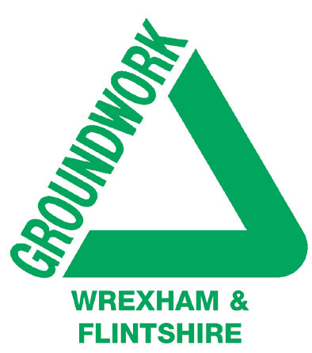
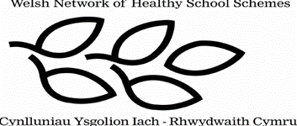

Peak Number 6:
Moel Morfydd

Height:
549m
Distance to summit:
2 ¼ miles
Time to summit:
1 ½ hours
Difficulty:
Moderate to Hard. Paths are clear (apart from at just one point – see below) but note that this is a steady climb from the moment you set out, and the section just below the summit is particularly steep. But think positive - Moel Morfydd makes you feel like a real mountaineer!
Directions:
From Llangollen take the A542 towards Ruthin. After 1 ½ miles (just past the Motor Museum), turn left where signed to Rhewl. Keep on this road (do not dip left to Corwen) and continue past Llantysilio to the first group of houses and the red brick chapel at Rhewl. After a further ½ mile you will reach the Sun Inn at a fork in the road.
Parking:
At the Sun Inn, Rhewl (Grid Ref. SJ 178 447). The proprietors are used to walkers and are very happy for you to park there, but would also appreciate your custom if possible.

The Area
Moel Morfydd is the last in a line of rounded heather-covered peaks collectively known as Llantysilio Ridge or Llantysilio Mountain. Although not the highest of these peaks (that distinction belongs to Moel-y-Gamelin at 577m), Moel Morfydd is the most easily recognisable from a distance because it has a ‘notch’ in its summit. Being a little farther west than the others, it also has the best view, looking down the length of the River Dee spanned by its viaducts, and out to the Shropshire plains.

The climb up Morfydd is certainly energetic, and reaching the summit here brings a real sense of achievement. But just one word of caution – choose a calm day for the climb, because a brisk breeze down in the valley will be transformed to a howling gale on the exposed summit.

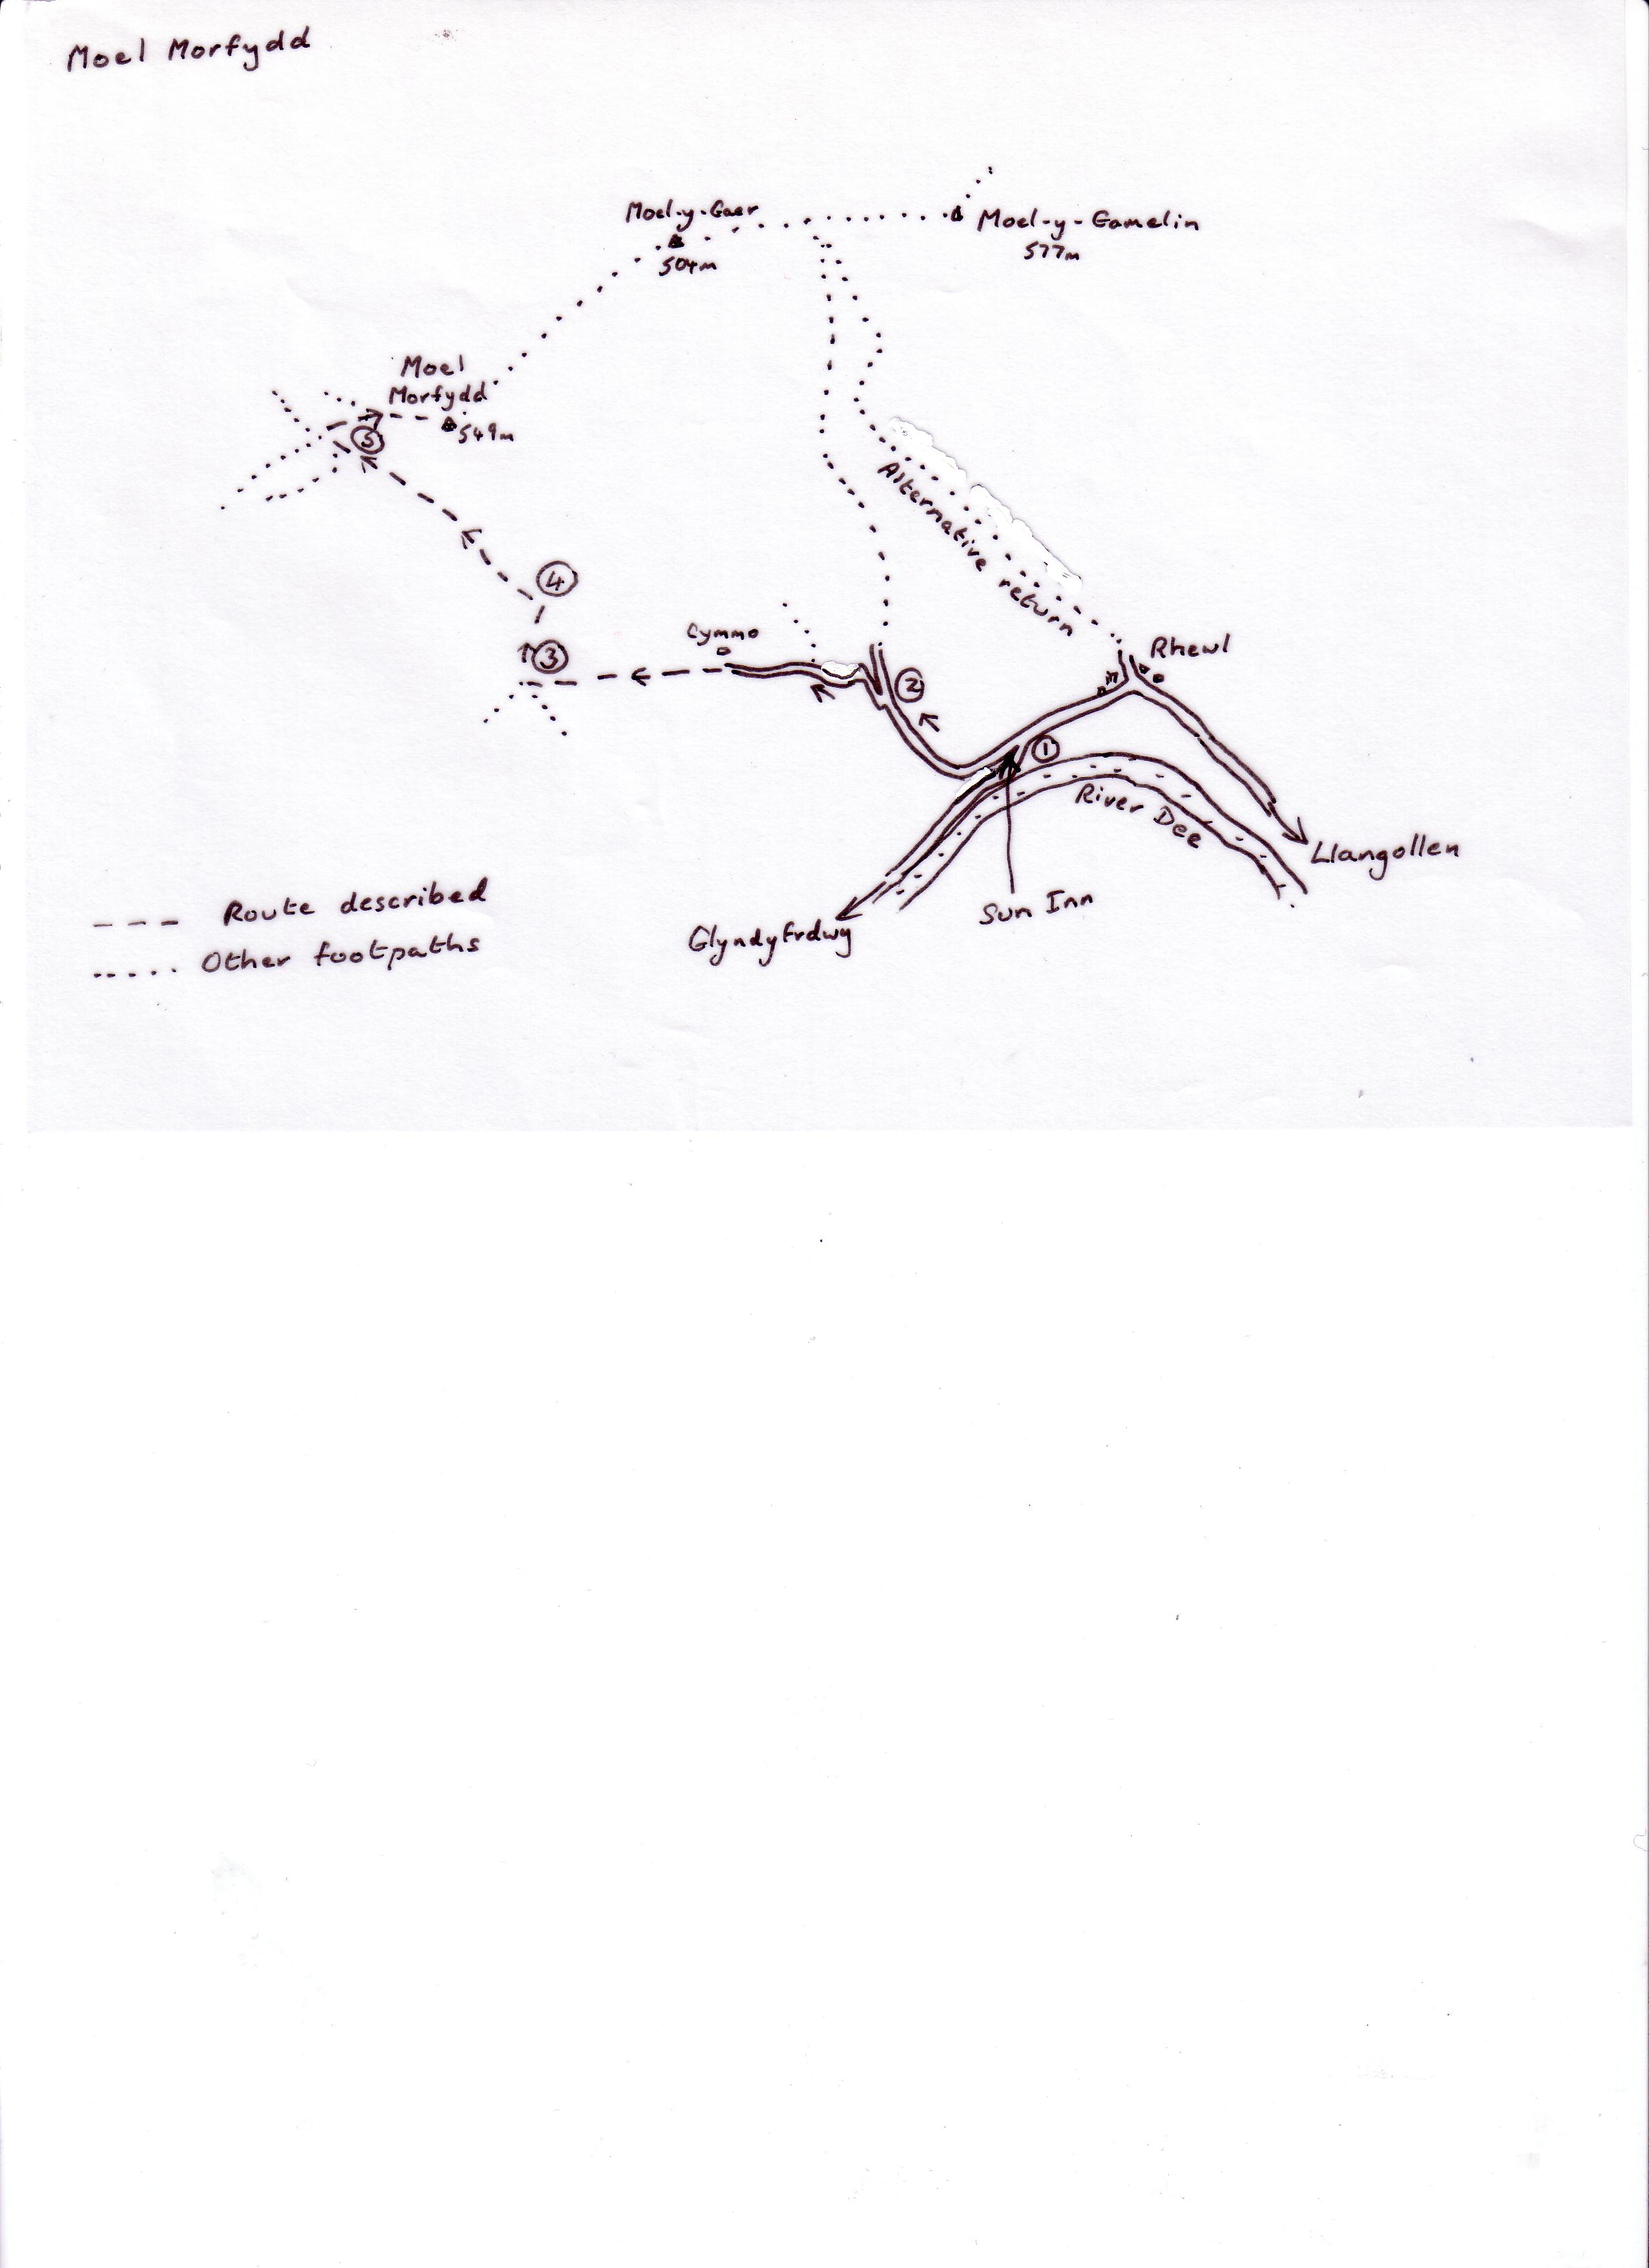

Directions for the Climb

- Leave the car park of the Sun Inn at the higher of the two exits and turn left. At the end of the line of houses, ignore the track leaving on the left and stay with the road, which then begins to climb.
- After about ½ mile the road forks. Keep left here, following the ‘Dee Valley Way’ signs on a road which then crosses a stream beside attractive white houses. Farther on you reach the white farm of Cymmo in the valley on your right. Here the hard-surfaced road ends and you continue in the same direction on a grassy track still bearing ‘Dee Valley Way’ signs. Over a stile the track climbs steadily as a sunken lane, with trees on the banks on either side. At one point you can go through a gateway into a field on the right, but stay with the track as long as possible – after all, this is the true right of way. Nevertheless there are one or two places where the track may be overgrown in summer and it is always possible to divert into the field if this is the case.
- After a long climb you reach is a four-way signpost at the top of the hill. The path ahead is now designated a bridleway, but you leave it and turn right towards the mountain. Keep the fence on your left, cut across the corner where it bends away and continue uphill to where a fence coming in on the left intersects. Here an apology for a stile (a couple of concrete blocks on the ground and a couple of planks in the wire) allows you to cross the fence. Continue very steeply uphill, now with the fence on your right, until you see a not-too-distinct grassy double-rutted track stretching away on your left – if you have climbed as high as the lone tree you have gone too far.
- Turn left and follow this track, which soon gathers strength and becomes much more obvious. The track runs almost horizontally for a while, and then forks. Take the right hand branch here, a track that climbs steadily up the flank of the mountain. Eventually it flattens out and is joined by another path from the left. The mountain summit is immediately to your right and you soon reach the very broad gravely track that makes the final ascent.
- Turn right and climb this track with care. Going up should not be a problem, although for the descent, it may be wiser to walk down the edge of the track on the grass and heather. The final assault is certainly steep, but it is fortunately only a few minutes before you reach the trig. height on the ‘notched’ summit, take your picture at this point.

At the Summit
You can see the broad rough track going on over Moel-y-Gaer to the big humpback of Moel-y-Gamelin. Beyond that mountain, the radio masts of Cyrn-y-Brain peep over the hill. Looking down rather than up, you can see Llangollen nestling at the foot of Castell Dinas Bran – and farther down the valley, the railway viaduct and road bridge (binoculars might help!).

Far, far back, the edge of Nesscliffe Hill and the rounded shoulder of the Wrekin stand side by side. Next look to the left of Cyrn-y-Brain and you can see the Dee estuary and Queensferry. Is it possible that you can see the Mersey and Liverpool behind? It certainly is! And before you leave, take a quick look at the sharp edge of the Berwyns in the south-west, the irregular lumpy Arenig Fawr to their right and farther over still, the impressive brooding mountains of Snowdonia.

An Alternative Way Down
You could always continue on the broad track over Moel-y-Gaer to the saddle between that mountain and Gamelin. If you turn right here and keep to the main track it will bring you down to the chapel in Rhewl. Simply turn right on the road to return to your car

Refreshment
The Sun Inn is a curiosity itself, a drover’s inn dating from the 14th century. The rooms inside are tiny with low-ceilings and heavy beams, and there is a pleasant little beer garden at the rear. Meals here are served every lunchtime and evening in the week and from midday to 10pm on Sundays - and the cuisine is just what you need after a day in the mountains!

