
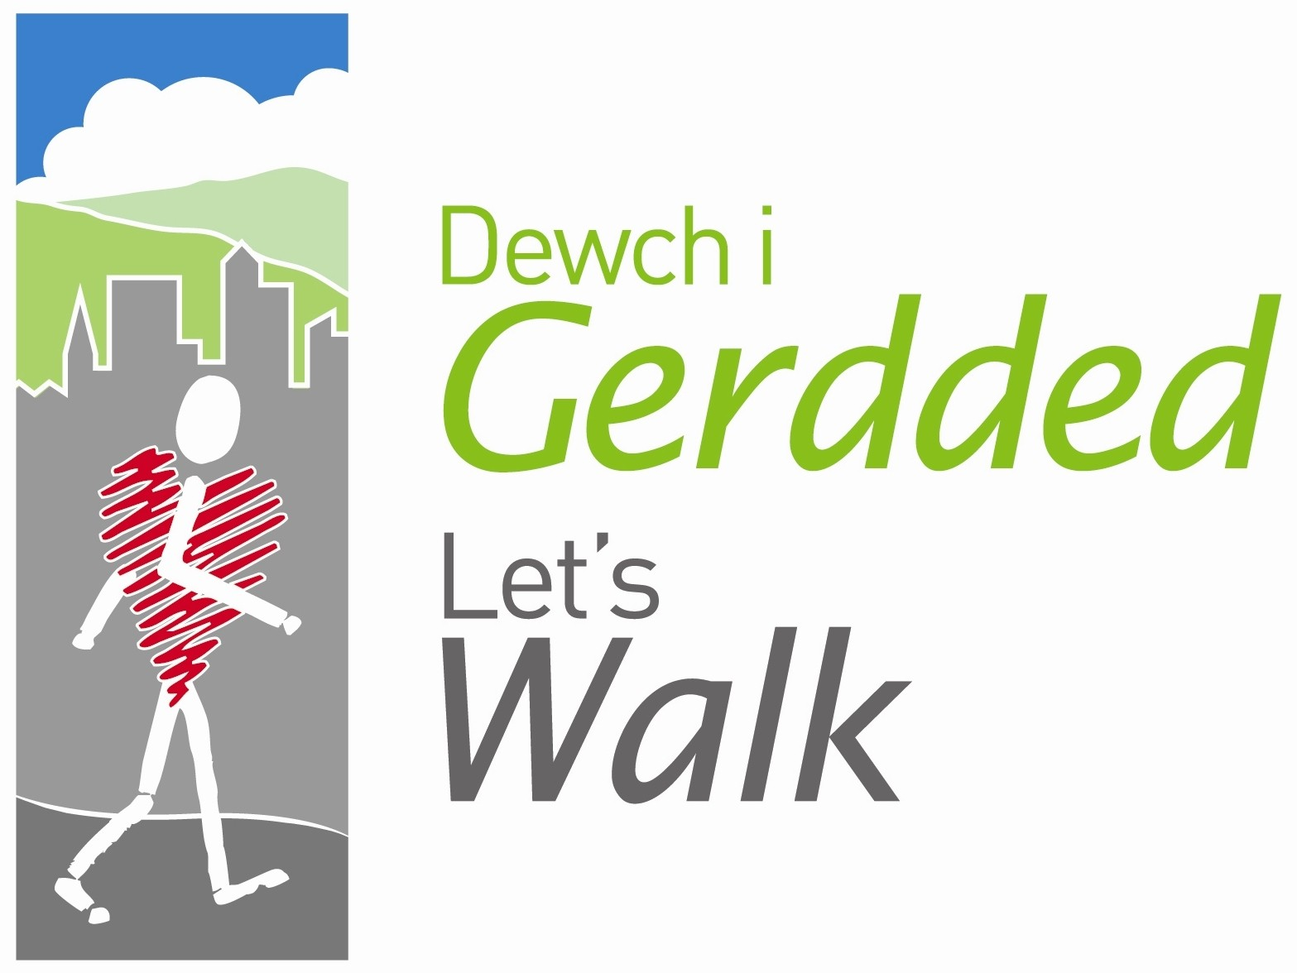

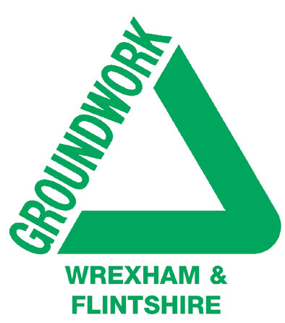
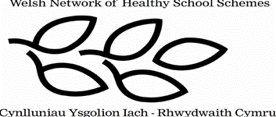

Peak Number 7:
Rodney’s Pillar (Breidden Hill)

Height:
365m
Distance to summit:
1 ½ miles
Time to summit:
50 mins
Difficulty:
Easy to Moderate. The first part of this route is on forest footpaths, and climbing is only very gentle. The final ascent to the Pillar is quite steep, but thankfully very short.
Directions:
From Wrexham take the A483 south through Llanymynech to Four Crosses. Here turn left on the B4393 and continue through Llandrinio to the village of Crewgreen. Ignore the right turn signed to Rodney’s Pillar (more about that later) and take a right turn about 300m later, signed to Bulthy. This narrow road climbs for about 1 ½ miles to reach a road junction – a road joins on the left and then there is a fork at which you should go right. After a further 1 ½ miles through beautiful countryside, look out for a fairly large unsigned car parking area on the left.
Parking:
At a roadside car park on the unclassified road heading south-west from Crewgreen between Middletown and Breidden Hills (Grid Ref. SJ 297 130).

The Area
Rodney’s Pillar is the most remarkable of the three Breidden Hills that seem to rise almost vertically from the Severn plain. The abrupt outline of these hills makes them easy to spot from a great distance away, and you have probably been able to pick them out from some of the other summits you have visited. Although the mountain you are climbing here is actually Breidden Hill, everyone knows it by the name of Rodney’s Pillar, the monument that stands on its summit.

In the 18th century, Admiral George Brydges Rodney achieved some spectacular naval victories against both French and Spanish fleets and this tall grey pillar was erected by local gentry in recognition of the fact that the ships he used were built of Montgomeryshire oak. In recent years the west side of the hill has been quarried to yield granite and basalt, which shows that these hills were once volcanoes!
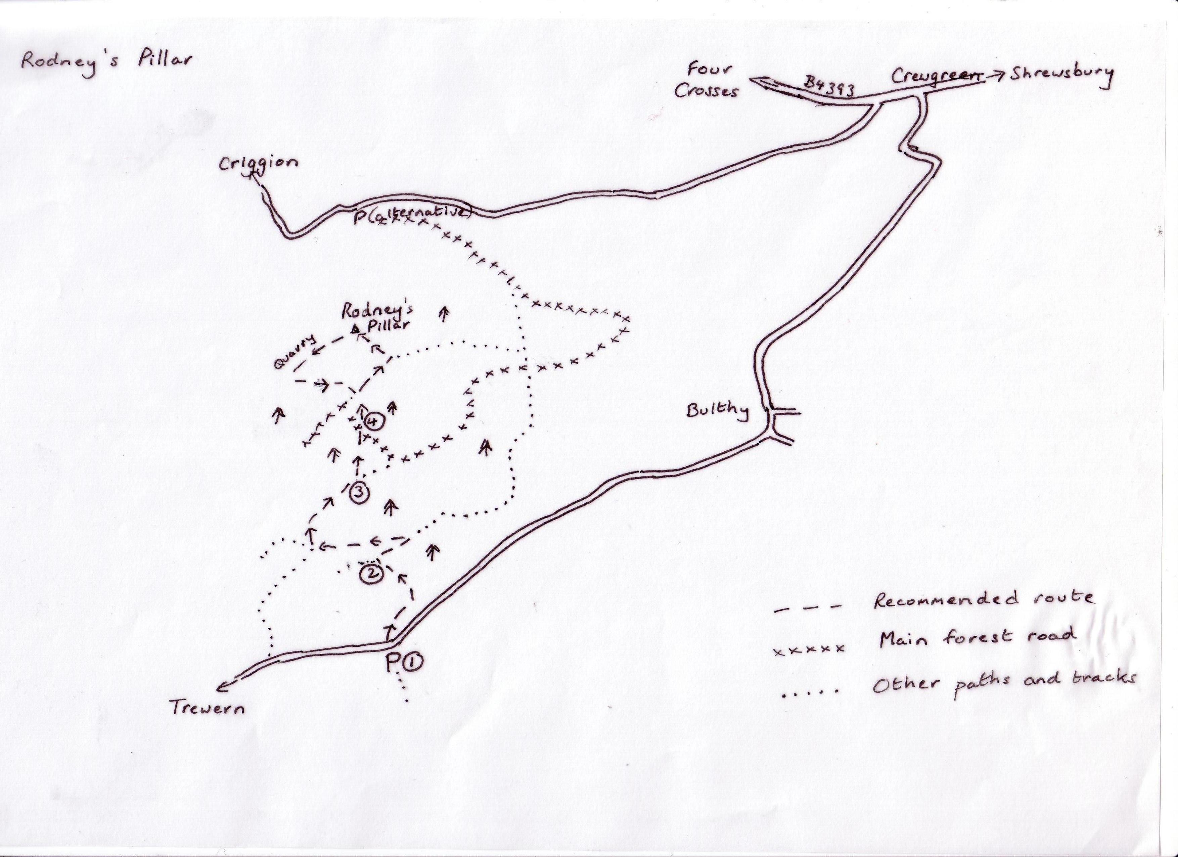

Directions for the Walk

- From the parking area cross the road to take the footpath on the opposite side. This curves away downhill to reach a house in the valley. Just before the house, take the stile on the left, cross the field and then go over a second stile where the path forks. Now take the left hand path, which climbs gently – although rather overgrown in summertime, its direction is still quite clear.
- Emerging suddenly at a wider track, turn right and follow it for some 300m to its junction with a hard-surfaced forest road. Turn left on the forest road, which after about 500m arrives at a clearing where several paths are marked with yellow footprint signs. Take the narrow but clear path immediately to your right, climbing between the pine trees around the flank of the hill. After descending a little, this path is joined by a bridleway and then continues to reach a path junction beside a high wire enclosure
- Turn left here and continue ahead for a few minutes to meet the main forest road.
- Cross the road, go down to the metal gate and turn right to reach a wooden signpost. From here you follow the yellow footprint signs – first straight on across the grassy plateau, and then left up the steep slope to arrive at Rodney’s Pillar.

At the Summit
First take a look at the pillar itself and if you like, take your picture here. Whichever way the wind is blowing, you can always shelter behind it to enjoy a picnic with a view! Down below you the infant River Severn wiggles through its valley and on the opposite side are the other two Breidden Hills, grassy-topped Middletown and the more wooded Moel y Golfa. If you then walk a little way across the flat summit you will find a first class orientation table identifying all the more distant mountains – in the south-west are the Long Mynd and the Wrekin, while on the opposite side you can see Plynlimmon, Cader Idris and even Snowdon on a clear day. From the orientation table you could continue by following the blue horseshoe bridleway signs which take you past the edge of the quarry (not dangerous) and through a little woodland to return to the signpost you passed in Point 4.

An Alternative Way Down?
There are many, many paths on this hill, some more overgrown than others. It’s simplest to return the way you came!

And An Alternative Way Up?
There are plenty of these, too. The main recommended route starts from a car park with picnic tables near the village of Criggion – just follow the signs to Rodney’s Pillar to find it. But Criggion is right down on the plain, and the route described here is much less demanding as it starts half way up the mountain, so to speak. Nevertheless you could consider the routes from Criggion and they are shown on a board in the car park. The easiest of these is the winding main forest road, 2 ½ miles in length, the second is a pretty vertical ascent through the forest (ideal for energetic teenagers), and the third – well, don’t even think it! All eventually arrive at the same point for the final short sharp ascent to the pillar described in Point 4.

Refreshment
There is a pub in Crewgreen and another on the road east of Criggion (the latter is predictably called the Admiral Rodney).

