
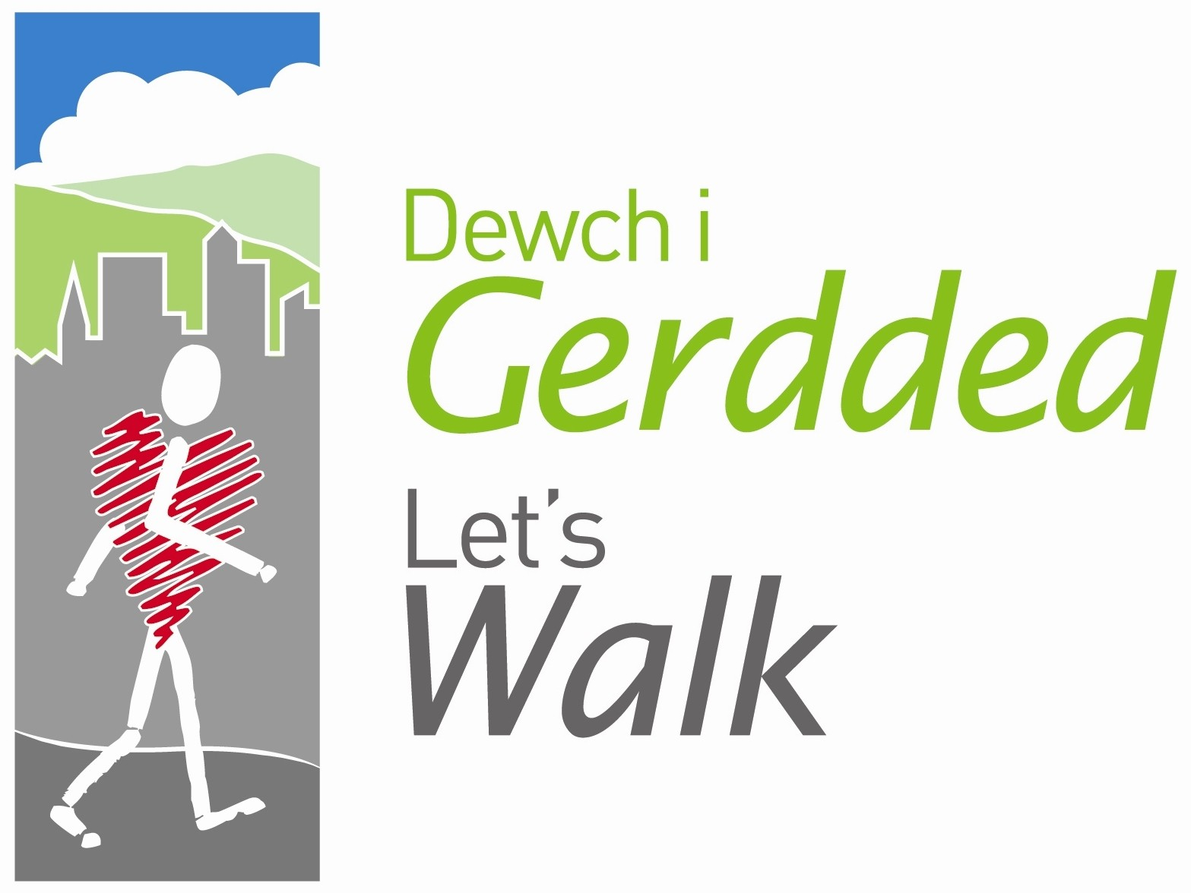




Peak Number 8:
Ruabon Mountain

Height:
470m
Distance to summit:
1 ½ miles
Time to summit:
45 mins
Difficulty:
Easy. A fairly well-defined path climbs steadily through the moorland to the summit.
Directions:
From Wrexham head out to Rhostyllen, and at the A483 junction, take the B5605 (the old Wrexham-Ruabon road) towards Rhosllanerchrugog. Now take the second road on the right (at the traffic lights), signed to Rhosllanerchrugog. At the mini-roundabout go right and then keep right to continue through the main street of Ponciau. At its end, continue straight ahead – you can see the Sun Inn ahead of you, after which the road leaves the town and climbs steadily towards the mountain. At the junction in about a mile, go right past Onnen Fawr, and at the end of the farm buildings, keep left. Continue on this road for about a mile until it bears left down to the reservoir – ahead of you at this point is the mountain gate, and on the left hand side of the road are a couple of small pull-offs where you can leave the car.
Parking:
At the mountain gate (Grid Ref. SJ 264 473).

The Area
Ruabon Mountain is part of the large upland mass that includes Eglwyseg Mountain and terminates on its west side in the dramatic limestone layers of the Eglwyseg Rocks. You aren’t going that far – this is just a simple walk to the summit to enjoy the views. A small cairn marks the highest point, and on the opposite side of the path, a cross of stones on the ground is a memorial to two airmen whose plane crashed here in the Second World War. Several other planes crashed on this mountain, which in 1940 was lit up at night to deceive the enemy into thinking it was Liverpool. Wreckage from the planes and even unexploded bombs are still to be found under the bilberries and heather – and if you add to all that some old quarries and disused mine shafts, you can see that it is important not to stray too far from the path when you make this climb. The views are splendid – and it seems that they must even have been enjoyed by prehistoric man, as there are many tumuli and standing stones on the wild mountain to the south of this path.
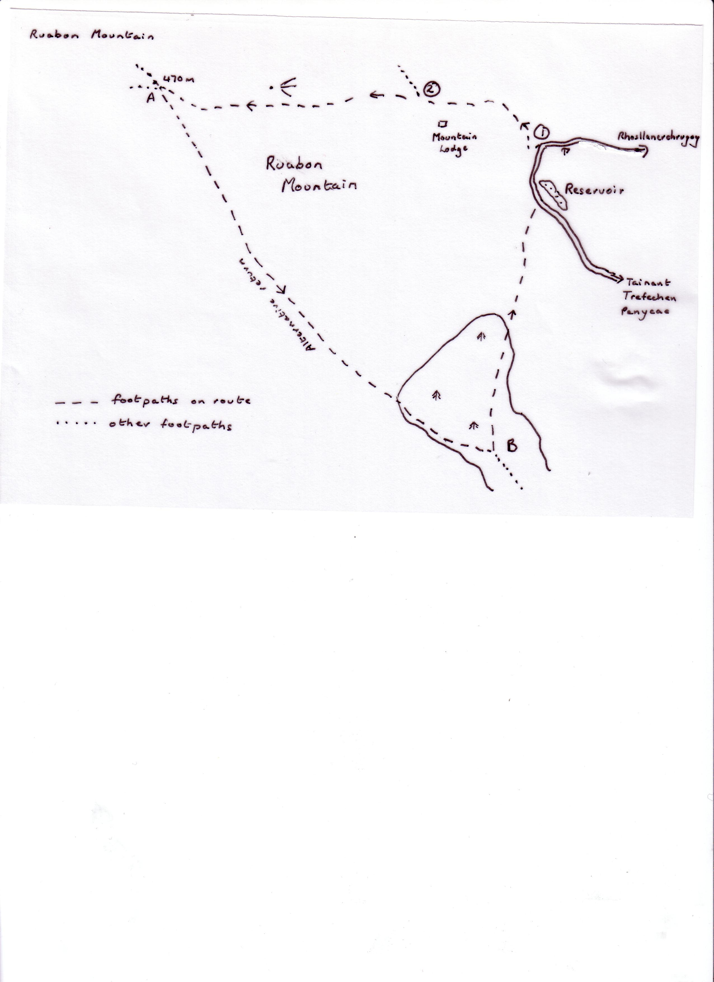

Directions for the Walk

- Through the mountain gate, the path first curves to the left. Its line is easy to follow and you are even assisted by a couple of marker posts with yellow arrows. After 10 minutes or so you can see the buildings of Mountain Lodge across the valley on the left.
- Shortly after this, a lesser path bears away to the right – ignore this and continue on the obvious track, which climbs gently and fairly steadily. Quite suddenly the view opens up in front of you and you realise you have reached the summit – although curiously there are higher rises of land to both left and right.

At the Summit

Look for the cairn on the right and the memorial cross on the left – both are just off the main path. Then there’s the view ahead – Cyrn-y-Brain with its radio masts is easily seen, as is the line of peaks known as Llantysilio Mountain (Y Faen, Y Gamelin, Y Gaer and Morfydd). Between Cyrn-y-Brain and Llantysilio Mountain you are looking into distant Snowdonia, while far away in the west, Arenig Fawr peeps out on the left of Llantysilio Mountain. Farther left still and very much nearer is the long ridge of the Berwyns. When you turn around to go back, all the Cheshire Plain is spread before you – the most obvious feature is the craggy line of the Peckforton Hills with Beeston Castle on the sharp little mound at the end of the line. Much farther to the right, the rounded hump of the Wrekin lifts the relatively flat horizon, and farther right still, you are in mountainous country again with the Breidden Hills backed by the Long Mynd.

An Alternative Way Down
If you fancy a fairly long (1 ½ hours approx) and occasionally boggy hike, follow the directions below.
A Just past the cairn and cross, a wide path crosses the main
track on which you climbed. Double back to the left on this
path through the heather and follow it across the flank of the
hill and then down into the valley of the Trefechan Brook. Do
not go down to the brook itself, but look for a waymarked
stile at the edge of the wood on the bank above. Cross this
and follow the obvious path.
B At a path junction in the valley (where you reach the hard-
surfaced road), take the bridleway to the left. This climbs up
another valley and eventually comes out to the road. Turn
left here and continue past the reservoir to the point where
you parked your car.

For less ambitious rambling, you could simply walk on over the other side of the mountain to where the path descends to World’s End. Don’t go down it (!) but take the broad sandy track to the right and then turn right again to return on one of the many other paths back to the summit.

Refreshment
Head to Ruabon and enjoy a meal in the Wynnstay Arms or if you fancy something different head to the Khazana Indian Restaurant on the A483. Alternatively visit the Little Chef on the A483 by Rhostyllen.

