


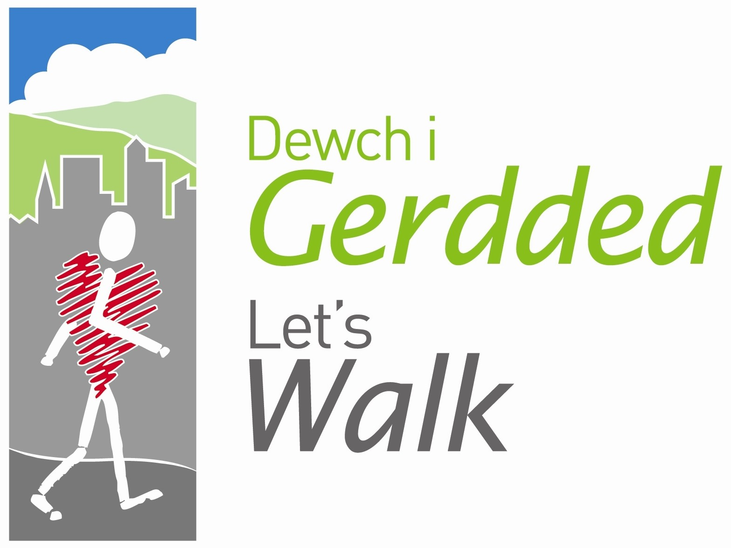

Advice on Dealing with Confrontations on walks

Walkers
If an altercation has begun involving walkers, try and stop the walk and deal with the situation with the other walk leader or a regular walker (as a witness, if you are alone). The priority is the walk continuing in a safe environment.

- Speak to walker(s) and establish the problem, try to determine who is at fault (if at all)
- Ask the walkers to put their differences aside until the end of the walk and separate the walkers to different areas of the walk
- If the problem persists, try and resolve the situation warning that they may have to leave the walk if the disturbance is continued
- If the problem persists, ask one or all involved parties to leave the walk (at your discretion)
- At the end of the walk, try to speak to all parties individually reminding them that the walks are for the public and they may be asked to leave on future walks if a similar situation arises

Members of the Public
If an altercation has begun involving a member of the public, try and lead the walk to a safe distance away from the area. With the other walk leader (or another walker – never on your own), try and deal with the situation calmly, the priority is to continue the walk in a safe environment or to safely lead walkers back to the start point if the walk cannot continue.

- Speak to member of the public and establish problem.
- If possible, deal with the complaint, if not, ask the MOP to contact the Walkabout Wrexham/Flintshire office.
- If MOP becomes aggressive, calmly remove yourself from the situation and if required, contact the Police on 999
- If the Police are called, note the appearance of the MOP and any other distinguishing features.
If the Police are called, the walk should be abandoned however it is the walk leader’s responsibility to get all walkers back to the start point safely. Please contact the Walkabout office as soon as possible to inform the coordinator of the incident.

